IAB internet advertising revenue report

2017 first six months results

*An industry survey conducted by PwC and sponsored by Interactive Advertising Bureau (IAB)*

*December 2017*

Table of contents

Background 1

Executive summary 2

Year-to-date revenues continue to show strong growth 3

Detailed findings 4

Shift from desktop to mobile expands 5

Continued historical quarterly revenue trends 6

Historical revenue mix – first half vs. second half 7

Revenue concentration 8

Ad format – second quarter 2017 results 9

Ad format – half year 2017 results 10

Historical Trends: Desktop vs. Mobile 11

Shifts occurred across the Search and Digtial Video formats 12

Digital Video – Mobile catches up to desktop 13

Social media advertising revenue 14

Digital audio - on track to exceed last year’s full-year revenue of $1.1B 15

Revenues by pricing model 16

# Background

## About the IAB internet advertising revenue report

Conducted by PwC Advisory Services LLC (“PwC”) on an ongoing basis, with results released quarterly, the “IAB Internet Advertising Revenue Report” was initiated by the Interactive Advertising Bureau (IAB) in 1996. This report utilizes data and information reported directly to PwC from companies selling advertising on the internet as well as publicly available corporate data.

The results reported are considered to be a reasonable measurement of internet/online/mobile advertising revenues because much of the data is compiled directly from information supplied by companies selling advertising online. The report includes data reflecting desktop and mobile online advertising revenues from websites, commercial online services, ad networks and exchanges, mobile devices, and email providers, as well as other companies selling online advertising.

The report is conducted independently by PwC on behalf   
of the IAB. PwC does not audit the information and   
provides no opinion or other form of assurance with   
respect to the information. Only aggregate results are published and individual company information is held   
in strict confidence with PwC. Further details regarding scope and methodology are provided in the appendix to   
this report.

***David Silverman***  
PwC

# Executive summary

## IAB internet advertising revenue report 2017 second quarter and first six months highlights

Internet advertising revenues (“revenues”) in the United States totaled $40.1 billion for the first six months of 2017, with Q1 2017 accounting for approximately $19.4 billion and Q2 2017 accounting for approximately $20.8 billion. Revenues for the first six months of 2017 increased 22.6% over the first six months of 2016.

### Key trends underlying Half-Year (HY) 2017 results

**Revenues increase 22.6% in HY 2017**  
Internet advertising revenues in the United States totaled $20.8 billion in the second quarter of 2017, an increase of 7.4% from the 2017 first-quarter total of $19.4 billion and an increase of 23.1% from the 2016 second-quarter total of $16.9 billion. Year-to-date revenues through June 2017 totaled $40.1 billion, up 22.6% from the $32.7 billion reported in 2016.

**The shift to mobile continues**

Advertising revenues delivered on mobile devices totaled $21.7 billion in HY 2017, a 40% increase from the prior half year revenues of $15.5 billion. Advertising delivered on a mobile device now make up 54% of total internet advertising revenues.

*“Being nimble and accessible are hallmarks of the new digital economy. Now, anyone with a good idea and a credit card can capture the attention of their customers directly, and this in turn represents an enormous growth opportunity for both marketers and publishers alike to help make these connections.”*

— Randall Rothenberg, President and CEO, IAB

*“We should no longer think of the internet as mobile vs desktop. Advertisers are simply following consumers, who live their lives online—whether on a smartphone during a commute, on a desktop at work, or on a tablet for entertainment in the evening. Digital is an intrinsic part of every American’s day.”*

— David Silverman, Partner, PwC

# Year-to-date revenues continue to show strong growth



Source: IAB/PwC Internet Ad Revenue Report, HY 2017

# Detailed findings

## Revenues totaled $20.8 billion in Q2 2017

Total second-quarter revenues were $3.9 billion (23.1%) higher than in the second quarter of 2016 and $1.4 billion (7.4%) higher than in the first quarter of 2017.

Source: IAB/PwC Internet Ad Revenue Report, HY 2017

**$16.9**

**$20.8**

Q2 16

Q2 17

**23.1%**

**Q2 2016 vs. Q2 2017**

**($ billions)**

**$19.4**

**$20.8**

Q1 17

Q2 17

**7.4%**

**Q1 2017 vs. Q2 2017**

**($ billions)**

# Shift from desktop to mobile expands

## For Q2 2017, mobile increased its share of internet advertising revenue to 54%

2017 second-quarter revenues increased 23.1% on a year-over-year basis, resulting in a 10-year compound annual growth rate (CAGR), 2008-2017, of 15.4%. On a year-over-year basis, mobile’s advertising revenue increased 40%, increasing its share of total revenues from 47% in HY 2016 to 54% in HY 2017. The result is a 6-year compound annual growth rate (CAGR) of 76.8%, reflecting an increase in total revenues from 2012 – 2017.

**2008 – 2017 ($ billions)**

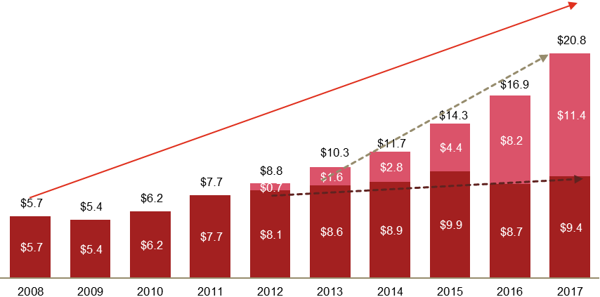

Mobile

Non-Mobile

***1515.4%******Overall CAGR***

***7676.8%******Mobile CAGR***

Source: IAB/PwC Internet Ad Revenue Report, HY 2017

# Continued historical quarterly revenue trends

## Quarterly growth continued upward trend

From the momentum built in 2010, internet advertising continues to show strong growth. After a recurring seasonal dip in Q1, Q2 2017 revenues continued to trend upward, although they remained below the high mark set in Q4 2016.

Since 2010, a strong seasonal trend has emerged for internet advertising revenues. With each annual cycle, revenue peaks in the fourth quarter, and is followed by a dip in the first quarter.



Source: IAB/PwC Internet Ad Revenue Report, HY 2017

# Historical revenue mix – first half vs. second half

## First half revenues reached $40.1 billion

Applying historical seasonal data, the first six months of 2017’s revenues ($40.1 billion) are on an expected annual run-rate to make 2017 the highest year in revenues, and on pace to exceed last year’s previous highest annual total of $72.5 billion.



Source: IAB/PwC Internet Ad Revenue Report, HY 2017

# Revenue concentration

## Top 10 companies command 75% of revenues in Q2 2017

Online advertising revenues remain concentrated with the 10 leading ad-selling companies, accounting for 75% of total revenues in Q2 2017, consistent with the percentage reported in Q2 2016. Companies ranked 11th to 25th accounted for 9% of revenues in Q2 2017, a two percentage point decrease from the 10% reported in Q2 2016.

The concentration of top 10 revenues have fluctuated over the past ten years, between 69% and 75%.



Source: IAB/PwC Internet Ad Revenue Report, HY 2017

|  |
| --- |
|  |



****

# Ad format – second quarter 2017 results

## Search related revenues as a percentage of total revenues decreased while digital video revenues continue to increase

* The Search format totaled revenues of $9.7 billion in Q2 2017, up 15% from Q2 2016 ($8.4 billion). The Search format’s representation of 47% of total internet advertising revenue for Q2 2017 is a slight year-over-year decrease from Q2 2016’s 49%.
* Digital video totaled $2.7 billion for Q2 2017, up $0.7 billion or 33%, from Q2 2016’s $2.1 billion.
* The Display-related* format totaled revenues of $9.3 billion in Q2 2017, up 29% from Q2 2016 ($7.2 billion). Display-related* advertising includes Banner Ads (31% of revenues or $6.5 billion), and Video (13% or $2.7 billion). Display-related* format’s representation of 45% of total internet advertising revenue for Q2 2017 is a slight year-over-year increase from  
  Q2 2016’s 43%.
* The Other** category, which accounted for 9% of Q2 2017 revenues is primarily comprised of Classifieds ($0.8 billion), Lead Generation ($0.7 billion), and Audio ($0.3 billion).

|  |
| --- |
| * Display-related formats include: Banners (Banners, Rich Media, and Sponsorship) and Video.  ** Other includes: Classifieds, Lead Generation, Audio, and Unspecified Other (“Unspecified Other” category was not specified by respondents).  *** Amounts may not equal 100% due to rounding and omission of minor categories.  **** Certain prior year amounts have been reclassified to conform with the current year presentation: |

|  |  |  |
| --- | --- | --- |
| ($ millions) | **As originally reported** | **As revised** |
| **Search** | $8,354 | $8,270 |
| **Banner** | $5,204 | $5,145 |
| **Video** | $2,025 | $2,001 |
| **Other** | $1,306 | $1,473 |

Source: IAB/PwC Internet Ad Revenue Report, HY 2017



****

|  |
| --- |
|  |

# Ad format – half year 2017 results

## The growth of display-related advertising revenue held for the first six months of 2017

* The Search format totaled revenues of $19.1 billion in HY 2017, up 18.4% from HY 2016  
  ($16.2 billion).
* The Search format’s representation of 48% of total internet advertising revenue for HY 2017 is a slight year-over-year decrease from HY 2016’s 49%.
* Digital Video totaled $5.2 billion for HY 2017, up $1.4 billion or 35.8% from HY 2016.
* The Display-related* format totaled revenues of $17.6 billion in HY 2017, up 28% from HY 2016 ($13.7 billion). Display-related* advertising includes Banner Ads (31% of HY 2017 revenues, or $12.4 billion), and Video (13% or $5.2 billion).
* Display-related* format’s representation of 44% of total internet advertising revenue for HY 2017 is a slight year-over-year increase from  
  HY 2016’s 42%.
* The Other** category, which accounted for 9% of total HY 2017 revenues was primarily composed of Classifieds ($1.5 billion), Lead Generation ($1.3 billion), and Audio ($0.6 billion).

|  |
| --- |
| * Display-related formats include: Banners (Banners, Rich Media, and Sponsorship) and Video.  ** Other includes: Classifieds, Lead Generation, Audio, and Unspecified Other (“Unspecified Other” category was not specified by respondents).  *** Amounts may not equal 100% due to rounding and omission of minor categories.  **** Certain prior year amounts have been reclassified to conform with the current year presentation: |

|  |  |  |
| --- | --- | --- |
| ($ millions) | **As originally reported** | **As revised** |
| **Search** | $16,325 | $16,160 |
| **Banner** | $9,980 | $9,863 |
| **Video** | $3,880 | $3,832 |
| **Other** | $2,554 | $2,884 |

Source: IAB/PwC Internet Ad Revenue Report, HY 2017

# Historical Trends: Desktop vs. Mobile

## The Shift to Mobile continues

* Mobile ad revenues continued to gain share, representing 54% of total HY 2017 revenues, as compared to 47% of total revenues reported in HY 2016 and 30% in HY 2015.
* Mobile, like Desktop, is comprised of multiple formats.



Source: IAB/PwC Internet Ad Revenue Report, HY 2017

# Shifts occurred across the Search and Digital Video formats

## Across desktop and mobile platforms, Search slips while Digital Video gains

* The Search format experienced minor growth across both desktop and mobile platforms, 4% and 37% respectively; however, the format also saw a reduction in percent of total revenue across both platforms, a loss of two percentage points on desktop and one percentage point on mobile.
* For HY 2017, the Digital Video format grew across both desktop and mobile platforms, 15% and 65% respectively.

***Desktop Ad formats HY 2016 v HY 2017***

***Mobile Ad formats  
HY 2016 v HY 2017\*\*\****

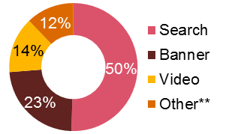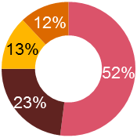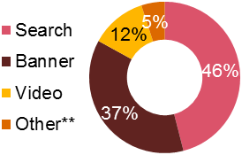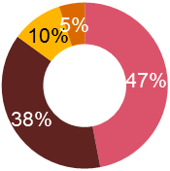

**$18.4 billion**

**$17.2 billion**

**2016\*\*\*\***

**2017**

|  |  |  |
| --- | --- | --- |
| ($ millions) | **As originally reported (mobile)** | **As revised (mobile)** |
| **Search** | $7,431 | $7,266 |
| **Banner** | $6,004 | $5,887 |
| **Video** | $1,628 | $1,580 |
| **Other** | $455 | $785 |

Source: IAB/PwC Internet Ad Revenue Report, HY 2017

* Display-related formats include: Banners (Banners, Rich Media, and Sponsorship) and Video.

** Other includes: Classifieds, Lead Generation, and Audio.

*** Amounts may not equal 100% due to rounding and omission of minor categories.

**** Certain prior year amounts have been reclassified to conform with the current year presentation

**2017**

**$15.5 billion**

**$21.7 billion**

**2016\*\*\*\***

# Digital Video – Mobile catches up to desktop

## In HY 17, mobile video revenue pulls alongside desktop video revenue for the first time

* Total digital video, including mobile and desktop, rose to $5.2 billion in HY 2017, up 37% from $3.8 billion in HY 2016.
* Growth of digital video on smartphones and tablets continued, reaching $2.6 billion in HY 2017, a 65% rise from HY 2016.
* On desktop, digital video continued to serve as the key growth driver in HY 2017, increasing 15% over HY 2016, to 2.6 billion.

**Historical Digital Video Revenues, Half Year** ($ billions)

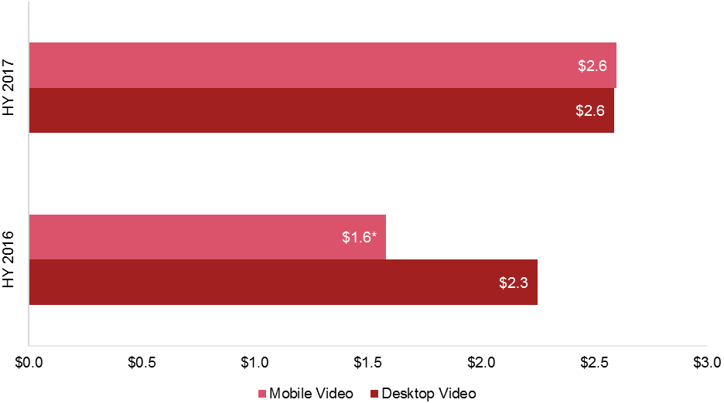

|  |  |  |
| --- | --- | --- |
| ($millions) | **As originally reported** | **As revised** |
| **Video** | $3,880 | $3,832 |

*Certain prior year amounts have been reclassified to conform with the current year presentation:

Source: IAB/PwC Internet Ad Revenue Report, HY 2017

# Social media advertising revenue

## Social Media advertising revenue totaled $9.5 billion for the first six months of 2017, compared to $7.0 billion in half year 2016

For the first half of 2017, Social Media revenue was $9.5 billion. Year-over-year, Social Media revenue was up 37% from HY 2016. Social continues its half-year growth trends - increases are reflected in the 51% compound annual growth rate of social from 2013 to 2017.

*Note: We define social media as advertising delivered on social platforms, including social networking and social gaming websites and apps, across all device types, including desktop, laptop, smartphone and tablet.*



Source: IAB/PwC Internet Ad Revenue Report, HY 2017

* CAGR: Compound Annual Growth Rate

# Digital Audio - on track to exceed last year’s full-year revenue of $1.1B

## The first six months of 2017 saw $603 million in audio advertising revenue

This represents a 42% increase over HY 2016’s revenue of $425 million. Additionally, digital audio advertising’s percentage of total internet advertising revenue spend increased from 1.3% in HY 16 to 1.5% in HY 17.



Source: IAB/PwC Internet Ad Revenue Report, HY 2017

*Podcast advertising revenue is not included in the digital audio advertising revenue figures for HY 2016 or HY 2017.

# Revenues by pricing model

## Performance-based pricing shows slight downtick while cost per medium/thousand shows slight uptick

* Approximately 65% of HY 2017 revenues were priced on a performance basis, consistent with the 65% reported in HY 2016.
* Approximately 33% of HY 2017 revenues were priced on a cost per medium/thousand (CPM) or impression basis, down slightly from the 34% reported in HY 2016.
* Approximately 2% of HY 2017 revenues were priced on a hybrid basis, a modest gain from the 1% reported in HY 2016.

Source: IAB/PwC Internet Ad Revenue Report, HY 2017

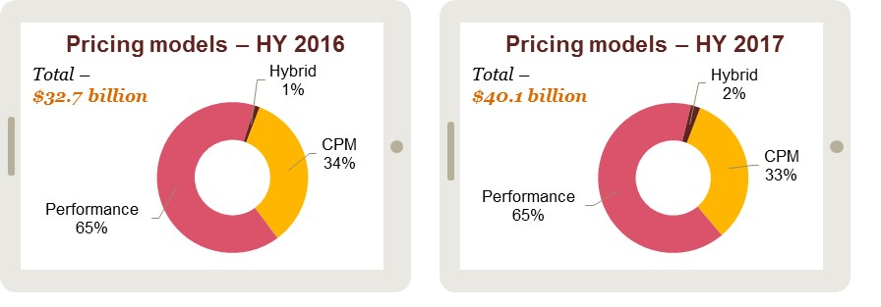

Historical pricing model trends

## Performance-based pricing resumes modest growth in HY 17

* Performance-based pricing, the leading pricing model since 2006, ticked up slightly to 65% of total revenue in HY 2017.
* CPM/impression-based pricing fell slightly in HY 2017, down to 33% of revenue from 34% in   
  HY 2016.
* Hybrid pricing increased to nearly 2% of total revenues in HY 2017, up from the 1% reported in HY 2016.



Source: IAB/PwC Internet Ad Revenue Report, HY 2017

* Pricing model definitions may have changed over the time period depicted both within the survey process and as interpreted by survey respondents.

Appendix

## Definitions of advertising formats and pricing models

|  |  |
| --- | --- |
| Banner advertising | Advertiser pays an online company for space on one or more of the online company’s pages to display a static or linked banner or logo. |
| Sponsorship | Advertiser pays for custom content and/or experiences, which may or may not include ad elements such as display advertising, brand logos, advertorial, or pre-roll video. Sponsorships fall into several categories:   * Spotlights are custom-built pages incorporating an advertiser’s brand and housing a collection of content usually around a theme * Advergaming can range from an advertiser buying all the ad units around a game or a “sponsored by” link to creating a custom branded game experience * Content & Section Sponsorship is when an advertiser exclusively sponsors a  particular section of the site or email (usually existing content) re-skinned with the advertiser’s branding * Sweepstakes & Contests can range from branded sweepstakes on the site to a full-fledged branded contest with submissions and judging |
| Email | Banner ads, links or advertiser sponsorships that appear in email newsletters, email marketing campaigns and other commercial email communications. This includes both ads within an email or the entire email. |
| Search | Fees advertisers pay online companies to list and/or link their company site domain name to a specific search word or phrase (includes paid search revenues). Search categories include:   * Paid listings – payments made for clicks on text links that appear at the top or side of search results for specific keywords. The more a marketer pays, the higher the position it gets. Marketers only pay when a user clicks on the text link. * Contextual search – payments made for clicks on text links that appear in an article based on the context of the content, instead of a user-submitted keyword. Payment only occurs when the link is clicked. * Paid inclusion – payments made to guarantee that a marketer's URL is indexed by a search engine (i.e. advertiser isn’t paid only for clicks, as in paid listings). * Site optimization – payments made to optimize a site in order to improve the site’s ranking in search engine results pages (SERPs). (For example, site owner pays a company to tweak the site architecture and code, so that search engine algorithms will better index each page of the site). |
| Lead generation | Fees paid by advertisers to online companies that refer qualified potential customers (e.g., auto dealers which pay a fee in exchange for receiving a qualified purchase inquiry online) or provide consumer information (demographic, contact, and behavioral) where the consumer opts in to being contacted by a marketer (email, postal, telephone, fax). These processes are priced on a performance basis (e.g., cost-per-action, -lead or -inquiry), and can include user applications (e.g., for a credit card), surveys, contests (e.g., sweepstakes) or registrations. |
| Classifieds and auctions | Fees paid to advertisers by online companies to list specific products or services (e.g., online job boards and employment listings, real estate listings, automotive listings, auction-based listings, yellow pages). |
| Rich media | Display-related ads that integrate some component of streaming interactivity. Rich media ads often include flash or java script, but not content, and can allow users to view and interact with products or services (e.g., scrolling or clicking within the ad opens a multimedia product description, expansion, animation, video or a “virtual test-drive” within the ad).  All IAB Rising Stars ad formats are considered Rich Media. Video commercials that appear in video players are considered Video Ads, not Rich Media.  “Interstitials” have been consolidated within the rich media category and represent full- or partial-page text and image server-push advertisements which appear in the transition between two pages of content. Forms of interstitials can include a variation of the following terms:   * Splash screens – a preliminary page that precedes the regular home page of a website that usually promotes a particular site feature or provides advertising. A splash page is timed to move onto the home page after a short period of time. * Pop-up ads and pop-under ads – an advertisement that appear in a separate window which automatically loads over an existing content window, without an associated banner. * Daughter windows – an advertisement that runs in a separate window associated with a concurrently displayed banner. The content and banner are typically displayed first, followed by the daughter window. * Superstitials – ads that are distinct from interstitials because of the much higher ad quality, and that they play instantly (ads are fully downloaded before they are displayed). |

## Definitions of advertising formats and pricing models

|  |  |
| --- | --- |
| Digital audio | Partially or entirely advertising-supported audio programming available to consumers on a streaming basis, delivered via the wired and mobile internet. This includes a wide range of services, such as the following:   * Online audio streams of terrestrial radio stations; * Purely online radio stations, with either professional or amateur DJs; * Personalized (i.e., without human editors/DJs) and on-demand, streamed audio services that create playlists based on user preferences of artists, tracks, or genres;   Music or spoken word audio content delivered within a different website or application, e.g., in-game music services.  Digital Audio is currently included in Other. |
| Digital video advertising | Advertising that appears before, during or after digital video content in a video player (i.e. pre-roll, mid-roll, post-roll video ads). Digital Video Ads include TV commercials online and can appear in streaming content or in downloadable video. Display-related ads on a page (that are not in a player) that contain video are categorized as rich media ads.  Video Overlays are also categorized as Digital Video Advertising. Video overlays include small ads that appear on top of digital video content. They can appear to be display, video, rich media, text or another ad format but are contained within the video player. |
| Mobile advertising | Advertising tailored to and delivered through wireless mobile devices such as smartphones, feature phones (e.g. lower-end mobile phones capable of accessing mobile content), and media tablets. Typically taking the form of static or rich media display ads, text messaging ads, search ads, or audio/video spots, such advertising generally appears within mobile websites (e.g. websites optimized for viewing on mobile devices), mobile apps (e.g. applications for Smartphones running proprietary or open operating systems), text messaging services (i.e. SMS, MMS) or within mobile search results (i.e., 411 listings, directories, mobile-optimized  search engines).  Mobile advertising formats include: Search, Display-related (banner ads,  video, audio, sponsorships, and rich media), and Other advertising served to  mobile devices. |
| Social media advertising | Advertising delivered on social platforms, including social networking and social gaming websites and apps, across all device types, including desktop, laptop, smartphone and tablet. |
| Impression-based | Cost-per-thousand (CPM) pricing model |
| Performance-based | Cost-per-click, sale, lead, acquisition, or application (e.g., credit card application) or straight revenue share (e.g., % commission paid upon sale) |
| Hybrid | Any mix of impression-based pricing plus performance-based compensation within one ad campaign |

## Survey scope and methodology

### Survey scope

The Interactive Advertising Bureau (IAB) retained PwC to establish a benchmark for measuring the growth of internet/online/mobile advertising revenues. The "IAB internet advertising revenue report" is part of an ongoing IAB mission to provide an accurate barometer of internet advertising growth.

To achieve differentiation from existing estimates and accomplish industry-wide acceptance, key aspects of the survey include:

* Obtaining historical data directly from companies generating internet/online/mobile advertising revenues;
* Making the survey as inclusive as possible, encompassing all forms of internet/online/mobile advertising, including websites, consumer online services, ad networks and exchanges, mobile devices, and email providers; and
* Ensuring and maintaining a confidential process, releasing only aggregate data.

### Methodology

PwC performs the following:

* Compiles a database of industry participants selling internet/online and mobile advertising revenues;
* Conducts a quantitative mailing survey with leading industry players, including Web publishers, ad networks and exchanges, commercial online service providers, mobile providers, email providers, and other online media companies;
* Acquires supplemental data through the use of publicly disclosed information;
* Requests and compiles several specific data items, including monthly gross commissionable advertising revenue by industry category and transaction;
* Identifies non-participating companies and applies a conservative revenue estimate based on available public sources; and,
* Analyzes the findings, identifies and reports key trends.

Historical data findings

## Annual and quarterly revenue growth

|  | Revenue (in mil) | | Q/Q Growth | Y/Y Growth |  |  | Revenue (in mil) | Q/Q Growth | Y/Y Growth |
| --- | --- | --- | --- | --- | --- | --- | --- | --- | --- |
| Q1 2003 | | $1,632 | 3% | 7% |  | Q1 2010 | $5,942 | -5% | 9% |
| Q2 2003 | | $1,660 | 2% | 14% |  | Q2 2010 | $6,185 | 4% | 14% |
| Q3 2003 | | $1,793 | 8% | 24% |  | Q3 2010 | $6,465 | 5% | 18% |
| Q4 2003 | | $2,182 | 22% | 38% |  | Q4 2010 | $7,449 | 15% | 19% |
| **Total 2003** | | **$7,267** |  | **21%** |  | **Total 2010** | **$26,041** |  | **15%** |
| Q1 2004 | | $2,230 | 2% | 37% |  | Q1 2011 | $7,264 | -2% | 22% |
| Q2 2004 | | $2,369 | 6% | 43% |  | Q2 2011 | $7,678 | 6% | 24% |
| Q3 2004 | | $2,333 | -2% | 30% |  | Q3 2011 | $7,824 | 2% | 21% |
| Q4 2004 | | $2,694 | 15% | 24% |  | Q4 2011 | $8,970 | 15% | 20% |
| **Total 2004** | | **$9,626** |  | **33%** |  | **Total 2011** | **$31,735** |  | **22%** |
| Q1 2005 | | $2,802 | 4% | 25% |  | Q1 2012 | $8,307 | -7% | 14% |
| Q2 2005 | | $2,985 | 7% | 26% |  | Q2 2012 | $8,722 | 5% | 14% |
| Q3 2005 | | $3,147 | 5% | 35% |  | Q3 2012 | $9,236 | 6% | 18% |
| Q4 2005 | | $3,608 | 15% | 34% |  | Q4 2012 | $10,307 | 12% | 15% |
| **Total 2005** | | **$12,542** |  | **30%** |  | **Total 2012** | **$36,570** |  | **15%** |
| Q1 2006 | | $3,848 | 7% | 37% |  | Q1 2013 | $9,806 | -5% | 18% |
| Q2 2006 | | $4,061 | 6% | 36% |  | Q2 2013 | $10,260 | 5% | 18% |
| Q3 2006 | | $4,186 | 3% | 33% |  | Q3 2013 | $10,609 | 3% | 15% |
| Q4 2006 | | $4,784 | 14% | 33% |  | Q4 2013 | $12,106 | 14% | 17% |
| **Total 2006** | | **$16,879** |  | **35%** |  | **Total 2013** | **$42,781** |  | **17%** |
| Q1 2007 | | $4,899 | 2% | 27% |  | Q1 2014 | $11,414 | -6% | 16% |
| Q2 2007 | | $5,094 | 4% | 25% |  | Q2 2014 | $11,678 | 2% | 14% |
| Q3 2007 | | $5,267 | 3% | 26% |  | Q3 2014 | $12,207 | 5% | 15% |
| Q4 2007 | | $5,946 | 13% | 24% |  | Q4 2014 | $14,152 | 16% | 17% |
| **Total 2007** | | **$21,206** |  | **26%** |  | **Total 2014** | **$49,451** |  | **16%** |
| Q1 2008 | | $5,765 | -3% | 18% |  | Q1 2015 | $13,179 | -7% | 16% |
| Q2 2008 | | $5,745 | 0% | 13% |  | Q2 2015 | $14,302 | 9% | 23% |
| Q3 2008 | | $5,838 | 2% | 11% |  | Q3 2015 | $14,688 | 3% | 20% |
| Q4 2008 | | $6,100 | 4% | 2% |  | Q4 2015 | $17,382 | 18% | 23% |
| **Total 2008** | | **$23,448** |  | **11%** |  | **Total 2015** | **$59,550** |  | **20%** |
| Q1 2009 | | $5,468 | -10% | -5% |  | Q1 2016 | $15,849 | -9% | 20% |
| Q2 2009 | | $5,432 | -1% | -5% |  | Q2 2016 | $16,889 | 7% | 18% |
| Q3 2009 | | $5,500 | 1% | -6% |  | Q3 2016 | $18,175 | 8% | 24% |
| Q4 2009 | | $6,261 | 14% | 3% |  | Q4 2016 | $21,607 | 19% | 24% |
| **Total 2009** | | **$22,661** |  | **-3%** |  | **Total 2016** | **$72,521** |  | **22%** |
|  | |  |  |  |  | Q1 2017 | $19,352 | -10% | 22% |
|  | |  |  |  |  | Q2 2017 | $20,786 | 7% | 23% |
|  | |  |  |  |  | **Total 2017** | **$40,138** |  |  |

Source: IAB/PwC Internet Ad Revenue Report, HY 2017

|  |  |  |
| --- | --- | --- |
| * Automotive * Beer/Wine/Liquor * Business Products/Services * Computers (Hardware/Software) and Consumer Electronics * Consumer Packaged Goods,  Food, Non-Alcoholic Beverages  and Candy * Educational Services * Entertainment (Film, Music,  TV, Box Office, Video Games, Amusement/Recreational) | * Financial Services (Banks, Insurance, Securities, Mortgages) * Personal Care, Toiletries, and Cosmetics * Drugs and Remedies * Manufacturing * Media * Professional Sports and  Sporting & Athletic Goods * Real Estate | * Restaurants/Fast Food * Retail, Mail Order, Catalogs  and Apparel * Telecommunications: Telephony, Cable/Satellite  TV Services, ISPs * Toys/Games * Leisure Travel (Airfare,  Hotels, Resorts) * Business Travel (Airfare,  Hotels, Resorts) |

## Survey industry categories

## About the interactive advertising bureau

The Interactive Advertising Bureau (IAB) empowers the media and marketing industries to thrive in the digital economy. It is comprised of more than 650 leading media and technology companies that are responsible for selling, distributing and optimizing digital advertising and marketing. Together, they account for 86 percent of online advertising in the United States. Working with its member companies, the IAB evaluates and recommends standards and practices and fields critical research on interactive advertising. The organization is committed to professional development, elevating the knowledge, skills, and expertise of individuals across the digital marketing industry. The IAB also educates marketers, agencies, media companies and the wider business community about the value of interactive advertising. Founded in 1996, the IAB is headquartered in New York City.

## Overall report guidance provided by IAB leadership

|  |  |  |
| --- | --- | --- |
| Executive committee | | |
| President and CEO  **Randall Rothenberg**  IAB  **Joe Apprendi**  Collective  **David Moore**  Xaxis | Chairman  **Lauren Wiener**  Tremor Video  **David Morris**  CBS Interactive  **Scott Schiller**  NBCUniversal | Vice Chair  **Jim Norton**  Condé Nast  **Vivek Shah**  Ziff Davis, LLC  **Rik van der Kooi**  Microsoft Advertising |

|  |  |  |
| --- | --- | --- |
| Ex-Officio | | |
| Founding Chairman  **Rich LeFurgy**  Archer Advisors | Treasurer  **John Toohey**  Charter Communications | Secretary  **Stu Ingis**  Venable LLP |

|  |  |  |
| --- | --- | --- |
| Board of Directors | | |
| **Lee Brown**  Buzzfeed  **Seth Dallaire**  Amazon Media Group  **Rick Erwin**  Acxiom  **Eric Franchi**  Undertone  **John Frelinghuysen**  Disney  **Keith Grossman**  Bloomberg  **Chris Guenther**  NewsCorp  **Jed Hartman**  The Washington Post  **Mark Howard**  Forbes Media  **Allie Kline**  AOL | **Meredith Kopit Levien**  The New York Times  **Seth Ladetsky**  Turner Broadcasting System  **Warren Lapa**  Spectrum Reach  **Jeff Lucas**  Snapchat  **Jean-Philippe Maheu**  Twitter  **Kirk McDonald**  PubMatic  **Marian Pittman**  Cox Media Group  **Penry Price**  LinkedIn  **Sridhar Ramaswamy**  Google  **Michael Rubenstein**  AppNexus | **Samantha Skey**  SheKnows Media  **Brad Smallwood**  Facebook  **Jeremy Steinberg**  The Weather Company  **John Trimble**  Pandora  **Lisa Utzshneider**  Yahoo  **Jacob Weisberg**  Slate  **Rick Welday**  AT&T AdWorks  **Steven Wolfe Pereira**  Neustar  **Troy Young**  Hearst Magazines Digital Media  **Joe Zawadzki**  MediaMath |

## PwC’s technology and entertainment, media, and communications practices

As business, accounting, and tax advisors to many of the world’s leading Entertainment, Media, and Communications (EMC) and Technology (Tech) companies, PwC (www.pwc.com) has an insider’s view of trends and developments driving the industry. With approximately 1,200 practitioners serving EMC and Tech clients in the United States, PwC is deeply committed to providing clients with industry experience and resources. In recent years, our pioneering work in EMC and Tech has included developing strategies to leverage digital technology, identifying new sources of financing, and marketplace positioning in industries characterized by consolidation and transformation. Our experience reaches across all geographies and segments of the EMC and Tech sectors, including broadband, wireless, the internet, music, film, television, publishing, advertising, gaming, theme parks, computers and networking, and software. With thousands of practitioners around the world, we're always close at hand to provide deep industry knowledge and resources.

### Our services include

* Business assurance services
* Web audience measurement and advertising delivery auditing and advisory
* IAB Measurement Certification Compliance auditing
* Privacy policy structuring, attestation, and compliance advisory
* Mergers & acquisitions assistance
* Tax planning and compliance
* Capital sourcing and IPO assistance
* Marketing & Media operations enablement

|  |  |  |
| --- | --- | --- |
| New York  **David Silverman**  Partner, Assurance Services  646.471.5421  [*david.silverman@us.pwc.com*](mailto:david.silverman@us.pwc.com) | New York  **Brian Gaffney**  Manager, Advisory Services  646.471.4722  [*brian.gaffney@us.pwc.com*](mailto:brian.gaffney@us.pwc.com) |  |
|  |  |

For more information, contact one of the following PwC professionals:

PwC has exercised reasonable care in the collecting, processing,   
and reporting of this information but has not independently   
verified, validated, or audited the data to verify the accuracy or   
completeness of the information. PwC gives no express or implied   
warranties, including but not limited to any warranties of   
merchantability or fitness for a particular purpose or use and shall   
not be liable to any entity or person using this document, or have   
any liability with respect to this document.

This content is for general information purposes only, and   
should not be used as a substitute for consultation with   
professional advisors.