

***IAB internet advertising  
revenue report***

2012 full year results

April 2013

An industry survey conducted by PwC and sponsored by the Interactive Advertising Bureau (IAB)

[www.pwc.com](mailto:www.pwc.com)  
[www.iab.net](mailto::www.iab.net)

Table of Contents

Background 3

Executive summary 4

Detailed findings

Historical trends 6

Ad formats 12

Industries 15

Pricing models 17

Advertising market share 19

Appendix 21

# Background

## About the IAB internet advertising revenue report

Conducted by PricewaterhouseCoopers LLP (“PwC”) on an ongoing basis, with results released quarterly, the “IAB Internet Advertising Revenue Report” was initiated by the Interactive Advertising Bureau (IAB) in 1996. This report utilizes data and information reported directly to PwC, publicly available online corporate data, and information provided by online ad selling companies.

The results reported are considered the most accurate measurement of internet/online/mobile advertising revenues because much of the data is compiled directly from information supplied by companies selling advertising online. All-inclusive, the report includes data reflecting online advertising revenues from websites, commercial online services, ad networks and exchanges, mobile devices, and e-mail providers, as well as other companies selling online advertising.

The report is conducted independently by PwC on behalf of the IAB. PwC does not audit the information and provides no opinion or other form of assurance with respect to the information. Only aggregate results are published and individual company information is held in strict confidence with PwC. Further details regarding scope and methodology are provided in the appendix to this report.



David Silverman  
PwC

# Executive summary

## 'IAB internet advertising revenue report' 2012 full year highlights

Internet advertising revenues (“revenues”) in the United States totaled $36.6 billion for the full year of 2012, with Q4 2012 accounting for approximately $10.3 billion and Q3 2012 totaling approximately $9.2 billion. Revenues for the full year of 2012 increased 15% over 2011.

**Key trends underlying 2012 results**

|  |
| --- |
| **Revenues increase 15% in 2012** — Internet advertising revenues in the United States totaled $10.31 billion in the fourth quarter of 2012, an increase of 12% from the 2012 third quarter total of $9.24 billion and an increase of 15% from the 2012 fourth quarter total $8.97 billion. 2012 full year internet advertising revenues totaled $36.57 billion, up 15% from the $31.74 billion reported in 2011.  *“These record-breaking numbers represent a paradigm shift when it comes to marketers recognizing the role a multiplicity of screens plays in effectively reaching today’s consumers. Mobile, in particular, soared due to its ubiquity and intrinsic ability to serve as a powerful digital dashboard that travels with you from morning commute to nighttime video viewing and beyond. The significant increase in digital video also underscores the importance of the upcoming Digital Content NewFronts and the vitality that sight, sound and motion play for both consumers and advertisers in the digital era.”*  — Randall Rothenberg, President and CEO, IAB |
| **Mobile advertising increases 111% in 2012** — Mobile advertising in the United States totaled $3.4 billion during the full year 2012, a 111% increase from the prior year total of $1.6 billion.  *“As smartphones get smarter, cellular networks get faster and user penetration of smart mobile devices increases, the combination of personalization and location will have tremendous appeal to marketers. We are just at the tip of the iceberg.”*  — David Silverman, Partner, PwC |

# Annual revenues show strong growth

|  |
| --- |
| **2011 vs. 2012, in billions** |

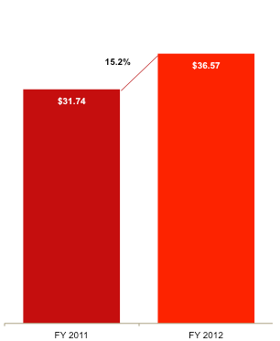

## Annual revenues for 2012 totaled $36.6 billion, $4.8 billion (or 15.2%) higher than in 2011.

# Detailed findings

## Revenues total a record $10.31 billion in Q4 2012

Total 2012 fourth quarter revenues broke the prior quarter record by $1.1 billion set in the third quarter of 2012.

2012 fourth quarter revenues represented the largest quarter on record, surpassing $10 billion in a quarter for the first time. Fourth quarter 2012 revenues were $1.34 billion (15%) higher than in the fourth quarter of 2011.

|  |  |  |
| --- | --- | --- |
| **Q4 11 vs. Q4 12 ($ billions)** |  | **Q3 12 vs. Q4 12 ($ billions)** |

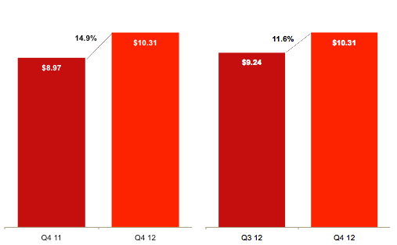

# Historical annual revenue trends

## Revenue continues strong growth in 2012

2012 annual revenues increased on a year-over-year percentage and dollar basis. The 19.7% CAGR* has far outpaced U.S. real GDP growth of 1.5%** over the same 10-year period.

|  |
| --- |
| **Annual revenue 2003-2012 ($ billions)** |

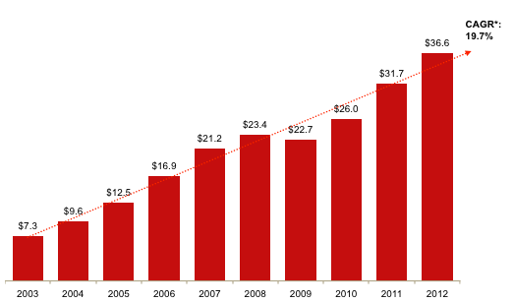

* CAGR: Compound Annual Growth Rate

** Source: Bureau of Economic Analysis, U.S. Department of Commerce

# Historical quarterly revenue trends

## Quarterly growth continues upward trend

Internet advertising continues to show strong growth from the recession related decline in 2009. After a seasonal related dip in Q1 2012, quarterly revenues continued to increase through 2012, with a seasonal boost of revenue in Q4 2012.

Since 2003, 80% of quarters (32 out of 40) have experienced positive growth over their prior quarter.

|  |
| --- |
| **Quarterly revenue growth trends 1996-2012 ($ billions)** |

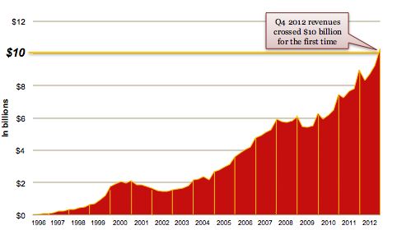

# Historical revenue mix – first-half vs. second-half

## Second-half revenues reach $19.5 billion

Second-half revenues totaled $19.5 billion in 2012, an increase of $2.7 billion from second-half revenues of 2011, which totaled $16.8 billion. Second-half revenues in 2012 represented 53% of total revenues in 2012, consistent with numbers reported in 2011 and consistent with the broader trend of higher revenues in the second-half of each year. The historically higher proportion of revenues in the second half of the year results primarily from the continued growth in the industry and, to a lesser extent, from fourth quarter seasonality.

|  |
| --- |
| **Historical revenue mix, first-half vs. second-half ($ billions)** |

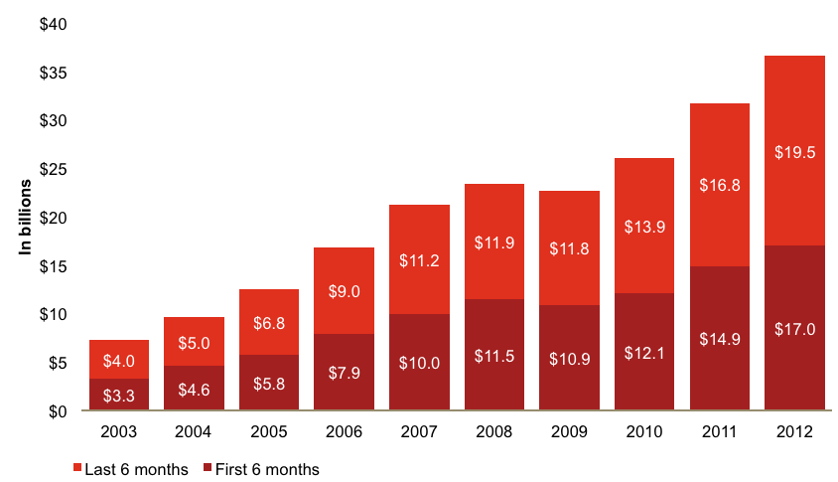

# Historical data findings

## Annual and quarterly revenue growth

|  | Revenue (in mil) | Q/Q Growth | Y/Y Growth |  |  | Revenue (in mil) | Q/Q Growth | Y/Y Growth |
| --- | --- | --- | --- | --- | --- | --- | --- | --- |
| Q1 2001 | $1,872 | -12% | -3% |  | Q1 2007 | $4,899 | 2% | 27% |
| Q2 2001 | $1,848 | -1% | -12% |  | Q2 2007 | $5,094 | 4% | 25% |
| Q3 2001 | $1,773 | -4% | -10% |  | Q3 2007 | $5,267 | 3% | 26% |
| Q4 2001 | $1,641 | -7% | -23% |  | Q4 2007 | $5,946 | 13% | 24% |
| **Total 2001** | **$7,134** |  | **-12%** |  | **Total 2007** | **$21,206** |  | **26%** |
| Q1 2002 | $1,520 | -7% | -19% |  | Q1 2008 | $5,765 | -3% | 18% |
| Q2 2002 | $1,458 | -4% | -21% |  | Q2 2008 | $5,745 | 0% | 13% |
| Q3 2002 | $1,452 | -1% | -18% |  | Q3 2008 | $5,838 | 2% | 11% |
| Q4 2002 | $1,580 | 9% | -4% |  | Q4 2008 | $6,100 | 4% | 2% |
| **Total 2002** | **$6,010** |  | **-16%** |  | **Total 2008** | **$23,448** |  | **11%** |
| Q1 2003 | $1,632 | 3% | 7% |  | Q1 2009 | $5,468 | -10% | -5% |
| Q2 2003 | $1,660 | 2% | 14% |  | Q2 2009 | $5,432 | -1% | -5% |
| Q3 2003 | $1,793 | 8% | 24% |  | Q3 2009 | $5,500 | 1% | -6% |
| Q4 2003 | $2,182 | 22% | 38% |  | Q4 2009 | $6,261 | 14% | 3% |
| **Total 2003** | **$7,267** |  | **21%** |  | **Total 2009** | **$22,661** |  | **-3%** |
| Q1 2004 | $2,230 | 2% | 37% |  | Q1 2010 | $5,942 | -5% | 9% |
| Q2 2004 | $2,369 | 6% | 43% |  | Q2 2010 | $6,185 | 4% | 14% |
| Q3 2004 | $2,333 | -2% | 30% |  | Q3 2010 | $6,465 | 5% | 18% |
| Q4 2004 | $2,694 | 15% | 24% |  | Q4 2010 | $7,449 | 15% | 19% |
| **Total 2004** | **$9,626** |  | **33%** |  | **Total 2010** | **$26,041** |  | **15%** |
| Q1 2005 | $2,802 | 4% | 25% |  | Q1 2011 | $7,264 | -2% | 22% |
| Q2 2005 | $2,985 | 7% | 26% |  | Q2 2011 | $7,678 | 6% | 24% |
| Q3 2005 | $3,147 | 5% | 35% |  | Q3 2011 | $7,824 | 2% | 21% |
| Q4 2005 | $3,608 | 15% | 34% |  | Q4 2011 | $8,970 | 15% | 20% |
| **Total 2005** | **$12,542** |  | **30%** |  | **Total 2011** | **$31,735** |  | **22%** |
| Q1 2006 | $3,848 | 7% | 37% |  | Q1 2012 | $8,307 | -7% | 14% |
| Q2 2006 | $4,061 | 6% | 36% |  | Q2 2012 | $8,722 | 5% | 14% |
| Q3 2006 | $4,186 | 3% | 33% |  | Q3 2012 | $9,236 | 6% | 18% |
| Q4 2006 | $4,784 | 14% | 33% |  | Q4 2012 | $10,307 | 12% | 15% |
| **Total 2006** | **$16,879** |  | **35%** |  | **Total 2012** | **$36,570** |  | **15%** |

# Revenue concentration

## Top 10 companies command 72% of revenues in Q4 2012

* Online advertising continues to remain concentrated with the 10 leading ad-selling companies, which accounted for 72% of total revenues in Q4 2012, up slightly from the 71% reported in Q4 2011.
* Companies ranked 11th to 25th accounted for 10% of revenues in Q4 2012, down slightly from the 11% reported in Q4 2011. Companies ranked 26th to 50th accounted for 7% in Q4 2012, down from the 8% reported in Q4 2011.

|  |
| --- |
| **% share of total revenues** |

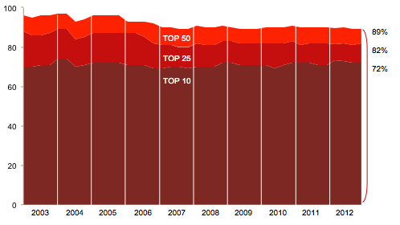

# Ad format – full year 2012 results

## Search and Display continue to lead ad formats, while Mobile growth remains strong

* Search revenues accounted for 46.3% of FY 2012 revenues, consistent with the 46.5% reported in FY 2011. Search totaled $16.9 billion in FY 2012 revenue, compared to $14.8 billion in FY 2011. This 14.5% increase is slightly below the overall industry growth of 15.2%, likely due to a shift to Mobile Search, now captured in the Mobile format.
* Display-related advertising accounted for $12.0 billion or 33% of total revenues during FY 2012, up 9% from the $11.1 billion (35% of total) reported in FY 2011. FY 2012 Display-related advertising includes Display/Banner Ads (21% of FY 2012 revenues, or $7.7 billion), Rich Media (3% or $1.1 billion), Digital Video (6% or $2.3 billion), and Sponsorship (2% or $845 million).
* Mobile revenues totaled 9% of FY 2012 revenues, or $3.4 billion, up 111% from the $1.6 billion (5% of total) reported in FY 2011. Mobile has experienced triple-digit percentage growth each year since PwC started capturing it in 2010.
* Classifieds revenues totaled $2.4 billion or 7% of FY 2012 revenues, down from the $2.6 billion (8% of total) reported in FY 2011.
* Lead Generation revenues accounted for 5% of FY 2012 revenues, or $1.7 billion, up 11% from the $1.5 billion (5% of total) reported in FY 2011.
* Email revenues accounted for 0.4% of FY 2012 revenues or $156 million, down 27% from the $213 million (0.7% of total) reported for FY 2011.

|  |  |  |
| --- | --- | --- |
| **Ad formats – full year 2011** |  | **Ad formats – full year 2012** |

Total - $31.7 billion* Total - $36.6 billion*

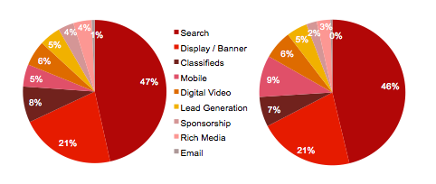

* Amounts may not equal 100% due to rounding.

# Ad format – fourth quarter 2012 results

## Search and Display continue to lead ad formats, while Mobile growth remains strong

* Search accounted for 44% of Q4 2012 revenues, down from 46% in Q4 2011. Search revenues totaled $4.6 billion in Q4 2012, compared to $4.2 billion in Q4 2011. This 10% increase is below the overall industry growth of 15%, likely due to a shift to Mobile Search, now captured in the Mobile format.
* Display-related advertising accounted for $3.4 billion or 33% of total revenues during Q4 2012, up 9% from the $3.2 billion (35% of total) reported in Q4 2011. Q4 2012 Display-related advertising includes Display/Banner Ads (21% of revenues, or $2.2 billion), Rich Media (3% or $326 million), Digital Video (7% or $676 million), and Sponsorship (2% or $241 million).
* Mobile revenues totaled 11% of Q4 2012 revenues, or $1.2 billion, up 115% from the $548 million (6% of total) reported in Q4 2011. Year-on-year Mobile growth has exceeded 90% each quarter since PwC started capturing it in 2010.
* Classifieds revenues totaled $651 million or 6% of Q4 2012 revenues, up 1% from the $648 million (7% of total) reported in Q4 2011.
* Lead Generation revenues accounted for 4% of Q4 2012 revenues, or $446 million, up 18% from the $377 million (4% of total) reported in Q4 2011.
* Email revenues accounted for 0.4% of Q4 2012 revenues or $41 million, down 45% from the $75 million (0.8% of total) reported for Q4 2011.

|  |  |  |
| --- | --- | --- |
| **Ad formats – Q4 2011** |  | **Ad formats – Q4 2012** |

Total - $8.97 billion* Total - $10.31 billion*

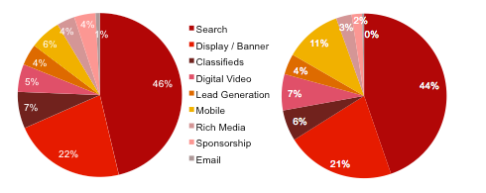

* Amounts may not equal 100% due to rounding.

# Historical format trends

## Search retains largest share of revenue, while Mobile grows fastest

* Search remains the leading format, having strong sequential growth through this period.
* All formats other than Digital Video are down slightly as a percentage of total revenue due to the substantial growth of Mobile.
* Mobile revenues showed the strongest growth of any format, representing 9% of total revenues in 2012 compared to 5% reported in 2011 and a negligible share as recently as 2009.
* Mobile growth should remain strong, with some features still untapped, such as location-based targeting and other innovative offerings and services that are simply not possible on computers.

|  |
| --- |
| **Advertising format share, 2006 - 2012 (% of total revenue)\*** |

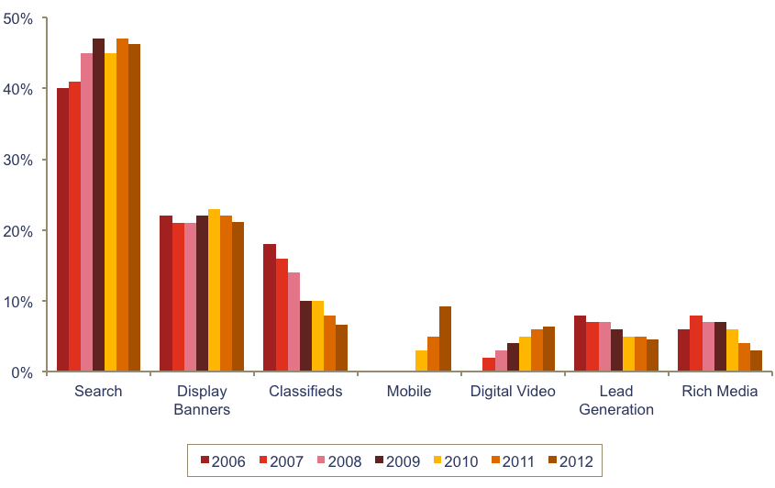

##### The surge in Mobile growth can be attributed to:

##### Growth in device penetration (Smartphone and tablet), led by Apple and Google

##### Faster connection speeds as 4G / LTE adoption is fueled by infrastructure and device upgrades

##### Improved screen resolutions that can squeeze more ads onto the mobile screen

##### Increased sophistication in incorporating ads into mobile apps and websites

##### Shifting social media consumption onto mobile devices

* Format definitions may have changed over the time period depicted, both within the survey process and as interpreted by survey respondents.

# Ad revenue percentages by industry category

## Retail drives advertising, as dollars shift to digital

* Retail advertisers, despite an overall decline, continue to represent the largest category of internet ad spending, accounting for 20% of revenues in 2012, down from the 22% reported in FY 2011.
* Telecom companies accounted for 11% of revenues in 2012, down slightly from the 12% reported in FY 2011.
* Financial Services advertisers accounted for 13% of revenues in 2012, consistent with the 13% reported in FY 2011.
* Automotive advertisers accounted for 12% of revenues in 2012, up from the 11% reported in FY 2011.
* Computing products advertisers represented 8% of revenues in 2012, down from the 9% reported in FY 2011.
* Leisure Travel (airfare, hotels, and resorts) accounted for 9% of revenues in 2012 up from 8% reported in FY 2011.
* Consumer Packaged Goods represented 7% in 2012, up from the 6% reported in FY 2011.
* Entertainment accounted for 4% of 2012 revenues, consistent with the 4% reported in FY 2011.
* Media accounted for 5% of 2012 revenues, consistent with the 5% reported in FY 2011.
* Pharma/Healthcare accounted for 6% of revenue in 2012, up from the 5% reported in FY 2011.

# Industry advertising – year-over-year comparatives

|  |
| --- |
| **Internet ad revenues by major industry category*, 2011 vs. 2012** |

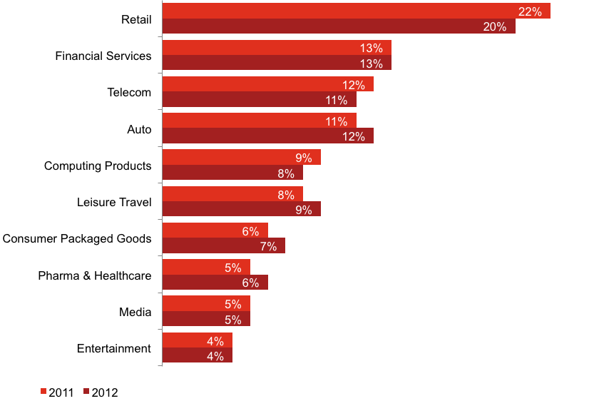

* Industry definitions may have changed over the time period depicted, both within the survey process and as interpreted by survey respondents. Amounts do not total to 100% as minor categories are not displayed.

# Revenues by pricing model

## Performance-based pricing gains interest

* Approximately 66% of FY 2012 revenues were priced on a performance basis, up from the 65% reported in FY 2011.
* Approximately 32% of FY 2012 revenues were priced on a cost per medium/thousand (CPM) or impression basis, up from the 31% reported in FY 2011.
* Approximately 2% of FY 2012 revenues were priced on a hybrid basis, down from the 4% reported in FY 2011.

|  |  |  |
| --- | --- | --- |
| **Pricing models – FY 2011** |  | **Pricing models – FY 2012** |

Total - $31.7 billion Total - $36.6 billion

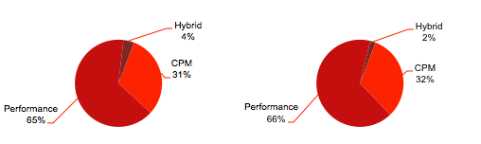

|  |  |  |
| --- | --- | --- |
| **Pricing models – Q4 2011** |  | **Pricing models – Q4 2012** |

Total - $8.97 billion Total - $10.31 billion

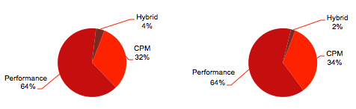

# Historical pricing model trends

## Performance-based pricing remains the preferred model

Performance-based pricing, the most prevalent pricing model since 2006, has maintained a strong sequential growth rate, reaching 66% in 2012. It is followed by CPM/impression-based pricing, which has stayed consistently at around 32% to 33% over the past three years. Hybrid pricing experienced the greatest loss in percentage revenue over the period, falling from 13% in 2005 to 2% in 2012. The continued decline of Hybrid is likely a result of the maturation of the market for the purchase and sale of internet advertising, with spend budgets increasingly allocated to specific, measurable outcomes.

|  |
| --- |
| **Internet ad revenues by pricing model\*** |



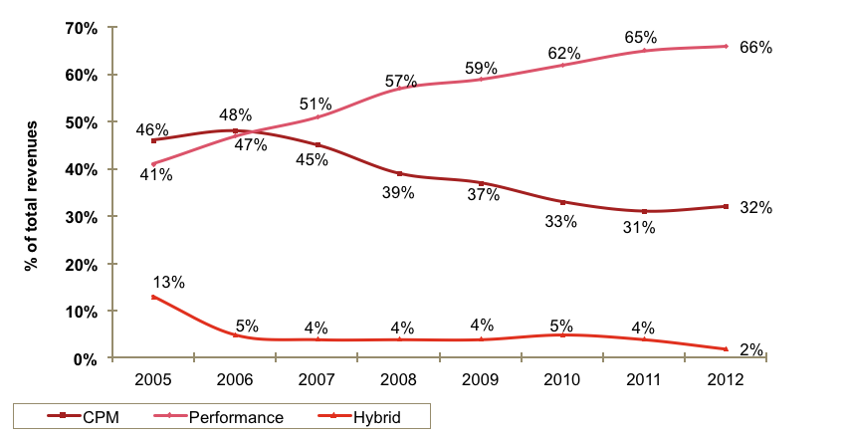

* Pricing model definitions may have changed over the time period depicted both within the survey process and as interpreted by survey respondents.

# Advertising market share by media

|  |
| --- |
| Internet advertising inches closer to Broadcast Television* advertising revenue  * Internet has continued to grow in significance when compared to other U.S. ad- supported media†. * In 2011, Internet advertising revenues surpassed those of Cable Television**; and in 2012, the gap between Internet and Broadcast Television* narrowed.   **Advertising revenue market share by media - 2011 ($ billions)** |

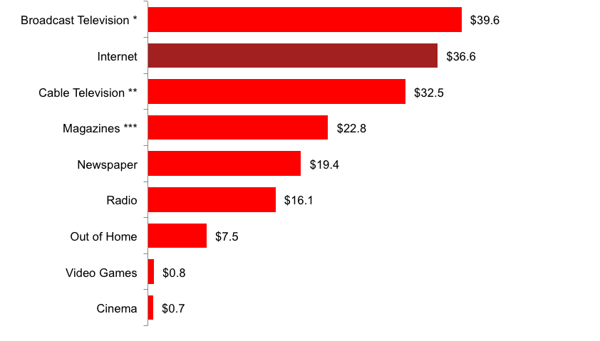

† The total U.S. advertising market includes other segments not charted here.

* Broadcast Television includes Network, Syndicated and Spot television advertising revenue.

** Cable Television includes National Cable Networks and Local Cable television advertising revenue.

*** Magazine includes Consumer and Trade magazines.

Sources: IAB Internet Advertising Revenue Report; PwC

# Historical advertising market share

## Internet advertising revenue growth outpaces other media outlets over the past eight years

* Two forms of media have positive compound annual growth rates (CAGR) between 2005 through 2011: Cable Television at 4.6% and Internet at 16.5%.
* In every year since 2005, the annual growth rates of Internet advertising have exceeded those of other advertising media.
* Internet advertising has experienced double-digit annual growth in every year except 2009; no other media has experienced double-digit growth in any year.

|  |
| --- |
| **Advertising revenue market share by media, 2005-2012 ($ billions)** |

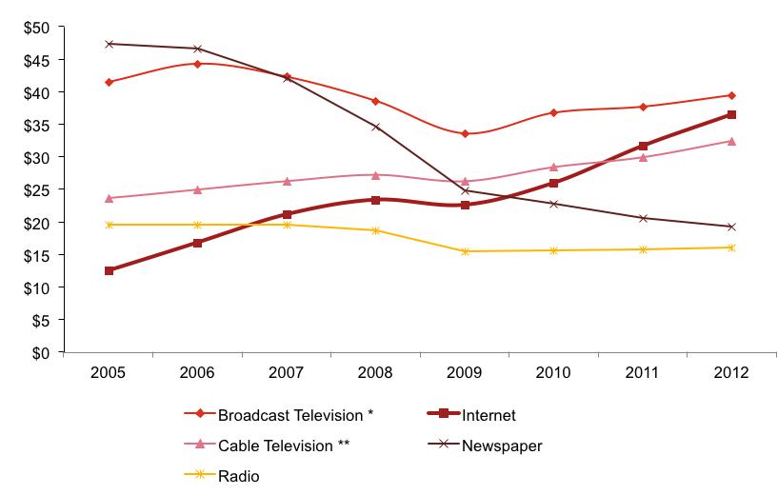

* Broadcast Television includes Network, Syndicated and Spot television advertising revenue.

** Cable Television includes National Cable Networks and Local Cable television advertising revenue.

Sources: IAB Internet Advertising Revenue Report; PwC

# Appendix

## Definitions of leading industry categories

The industry categories used in the “IAB Internet Advertising Revenue Report” were sourced from the North American Standard Industrial Classification (SIC) Manual.†

|  |  |
| --- | --- |
| Retail | Includes mail order/catalog, apparel, restaurants/fast food, home furnishings/textiles, toys, pet food/supplies, appliances, jewelry, drugstores, retail stores, and cosmetics stores. |
| Automotive | Includes all automotive-related categories including sale/purchase of vehicles and parts and maintenance. |
| Entertainment | Includes film, music, TV, box office, video games, and amusement & recreation. |
| Consumer packaged goods | Includes packaged goods, food products, household products, and tobacco. |
| Leisure travel | Includes travel, hotel, airlines, and resorts. |
| Computing products | Includes hardware (computers, computer storage devices, and computer peripheral equipment), consumer electronics, prepackaged software (operating, utility, and applications programs), local area network systems and network systems integration, computer processing, and data preparation and data processing services. |
| Financial Services | Includes commercial banks, credit agencies, personal credit institutions, consumer finance companies, loan companies, business credit institutions, and credit card agencies. Also includes companies engaged in the underwriting, purchase, sale, or brokerage of securities and other financial contracts. |
| Telecommun-ications | Includes point-to-point communications services, including cellular phone services, paging services, wireless internet access, and wireless video services. Includes multichannel video providers on a subscription fee basis (e.g., cable television, wireless cable television, and direct broadcast satellite services). |
| Pharma & Healthcare | Includes pharmaceutical products, facilities, services, researchers, and biological products. Also comprises establishments providing healthcare and social assistance for individuals as well as personal care, toiletries, and cosmetic products. |
| Media | Includes establishments primarily engaged in radio and television broadcasting (network and station) including commercial, religious, educational, and other radio or television stations. Also includes establishments primarily engaged in publishing newspapers, periodicals, and books. |

†Survey participants reported results based on the 20 industry categories listed on page 24, which were used specifically for the “IAB Internet Advertising Revenue Report.” This is consistent with other relevant industry categorization sources that measure advertising spending by industry. For purposes of this report, PwC classified a number of individual categories under “Retail.”

## Definitions of advertising formats

|  |  |
| --- | --- |
| Display Advertising | Advertiser pays an online company for space on one or more of the online company’s pages to display a static or linked banner or logo. |
| Sponsorship | Advertiser pays for custom content and/or experiences, which may or may not include ad elements such as display advertising, brand logos, advertorial, or pre-roll video. Sponsorships fall into several categories:  Spotlights are custom-built pages incorporating an advertiser’s brand and housing a collection of content usually around a theme  Advergaming can range from an advertiser buying all the ad units around a game or a “sponsored by” link to creating a custom branded game experience  Content & Section Sponsorship is when an advertiser exclusively sponsors a particular section of the site or email (usually existing content) re-skinned with the advertiser’s branding  Sweepstakes & Contests can range from branded sweepstakes on the site to a full-fledged branded contest with submissions and judging |
| Email | Banner ads, links or advertiser sponsorships that appear in email newsletters, email marketing campaigns and other commercial email communications. This includes both ads within an email or the entire email. |
| Search | Fees advertisers pay online companies to list and/or link their company site domain name to a specific search word or phrase (includes paid search revenues). Search categories include:  Paid listings – payments made for clicks on text links that appear at the top or side of search results for specific keywords. The more a marketer pays, the higher the position it gets. Marketers only pay when a user clicks on the text link.  Contextual search – payments made for clicks on text links that appear in an article based on the context of the content, instead of a user-submitted keyword. Payment only occurs when the link is clicked.  Paid inclusion – payments made to guarantee that a marketer's URL is indexed by a search engine (i.e. advertiser isn’t paid only for clicks, as in paid listings).  Site optimization – payments made to optimize a site in order to improve the site’s ranking in search engine results pages (SERPs). (For example, site owner pays a company to tweak the site architecture and code, so that search engine algorithms will better index each page of the site). |
| Lead Generation | Fees paid by advertisers to online companies that refer qualified potential customers (e.g., auto dealers which pay a fee in exchange for receiving a qualified purchase inquiry online) or provide consumer information (demographic, contact, behavioral) where the consumer opts in to being contacted by a marketer (email, postal, telephone, fax). These processes are priced on a performance basis (e.g., cost-per-action, -lead or -inquiry), and can include user applications (e.g., for a credit card), surveys, contests (e.g., sweepstakes) or registrations. |
| Classifieds and Auctions | Fees paid to advertisers by online companies to list specific products or services (e.g., online job boards and employment listings, real estate listings, automotive listings, auction-based listings, yellow pages). |
| Rich Media | Display-related ads that integrate some component of streaming interactivity. Rich media ads often include flash or java script, but not content, and can allow users to view and interact with products or services (e.g., scrolling or clicking within the ad opens a multimedia product description, expansion, animation, video or a “virtual test-drive” within the ad). IAB Rising Stars ad formats are considered Rich Media. Video commercials that appear in video players are considered Digital Video Ads, not Rich Media.  “Interstitials” have been consolidated within the rich media category and represent full- or partial-page text and image server-push advertisements which appear in the transition between two pages of content. Forms of interstitials can include a variation of the following terms:  Splash screens – a preliminary page that precedes the regular home page of a website that usually promotes a particular site feature or provides advertising. A splash page is timed to move onto the home page after a short period of time.  Pop-up ads and pop-under ads – an advertisement that appear in a separate window which automatically loads over an existing content window, without an associated banner.  Daughter windows – an advertisement that runs in a separate window associated with a concurrently displayed banner. The content and banner are typically displayed first, followed by the daughter window.  Superstitials – ads that are distinct from interstitials because of the much higher ad quality, and that they play instantly (ads are fully downloaded before they are displayed). |

## Definitions of advertising formats (cont.)

|  |  |
| --- | --- |
| Digital Video Advertising | Advertising that appears before, during or after digital video content in a video player (i.e. pre-roll, mid-roll, post-roll video ads). Digital Video Ads include TV commercials online and can appear in streaming content or in downloadable video. Display-related ads on a page (that are not in a player) that contain video are categorized as rich media ads.  Video Overlays are also categorized as Digital Video Advertising. Video overlays include small ads that appear on top of digital video content. They can appear to be display, video, rich media, text or another ad format but are contained within the video player. |
| Mobile Advertising | Advertising tailored to and delivered through wireless mobile devices such as smartphones (e.g. Blackberry, iPhone, Android, etc.), feature phones (e.g. lower-end mobile phones capable of accessing mobile content), and media tablets (e.g. iPad, Samsung Galaxy Tablet, etc.). Typically taking the form of static or rich media display ads, text messaging ads, search ads, or audio/video spots, such advertising generally appears within mobile websites (e.g. websites optimized for viewing on mobile devices), mobile apps (e.g. applications for Smartphones running iOS, Android, Windows Mobile or other operating systems), text messaging services (i.e. SMS, MMS) or within mobile search results (i.e., 411 listings, directories, mobile-optimized search engines). |

## Survey scope and methodology

### Survey scope

The Interactive Advertising Bureau (IAB) retained PwC to establish a comprehensive standard for measuring the growth of internet advertising revenues.

* The “IAB internet advertising revenue report” is part of an ongoing IAB mission to provide an accurate barometer of internet advertising growth.
* To achieve differentiation from existing estimates and accomplish industry-wide acceptance, key aspects of the survey include:
  + Obtaining historical data directly from companies generating internet advertising revenues, inclusive of wired and mobile;
  + Making the survey as inclusive as possible, encompassing all forms of internet advertising, including websites, consumer online services, ad networks, mobile devices, and e-mail providers; and
  + Ensuring and maintaining a confidential process, releasing only aggregate data.

### Methodology

PwC performs the following:

* Compiles a database of industry participants selling internet advertising revenues
* Conducts a quantitative mailing survey with leading industry players, including Web publishers, ad networks, commercial online service providers, mobile providers, e-mail providers, and other online media companies
* Acquires supplemental data through the use of publicly disclosed information
* Requests and compiles several specific data items, including monthly gross commissionable advertising revenue by industry category and transaction
* Identifies non-participating companies and applies a conservative revenue estimate based on available public sources
* Analyzes the findings, identifies and reports key trends

## Survey industry categories

|  |  |  |
| --- | --- | --- |
| Automotive  Beer/Wine/Liquor  Business Products/Services  Computers (Hardware/Software) and Consumer Electronics  Consumer Packaged Goods, Food, Non-Alcoholic Beverages and Candy  Educational Services  Entertainment (Film, Music, TV, Box Office, Video Games, Amusement/Recreational) | Financial Services (Banks, Insurance, Securities, Mortgages)  Personal Care, Toiletries, and Cosmetics  Drugs and Remedies  Manufacturing  Media  Professional Sports and Sporting & Athletic Goods  Real Estate | Restaurants/Fast Food  Retail, Mail Order, Catalogs and Apparel  Telecommunications: Telephony, Cable/Satellite TV Services, ISPs  Toys/Games  Leisure Travel (Airfare, Hotels, Resorts)  Business Travel (Airfare, Hotels, Resorts) |

## About the Interactive Advertising Bureau

The Interactive Advertising Bureau (IAB) is comprised of more than 500 leading media and technology companies that are responsible for selling 86% of online advertising in the United States. On behalf of its members, the IAB is dedicated to the growth of the interactive advertising marketplace, of interactive’s share of total marketing spend, and of its members’ share of total marketing spend. The IAB educates marketers, agencies, media companies and the wider business community about the value of interactive advertising. Working with its member companies, the IAB evaluates and recommends standards and practices and fields critical research on interactive advertising. Founded in 1996, the IAB is headquartered in New York City with a Public Policy office in Washington, D.C. For more information, please visit www.iab.net.

## Overall report guidance provided by IAB leadership

|  |  |  |
| --- | --- | --- |
| Executive Committee | | |
| President  **Randall Rothenberg** IAB  **Leon Levitt** CMG Digital  **David Moore** 24/7 Real Media, Inc. | Chairman  **Randy Kilgore** Tremor Media  **Bill Todd** ValueClick Media | Vice Chair  **Vivek Shah**  Ziff Davis, Inc.  **Rik van der Kooi** Microsoft Advertising  **Denise Warren**  The New York Times Company |

|  |  |  |
| --- | --- | --- |
| Ex-Officio | | |
| Founding Chairman  **Rich LeFurgy** Archer Advisors | Treasurer  **Bruce Gordon** Disney Interactive Media Group | Secretary  **Joe Rosenbaum** Reed Smith LLP |

|  |  |  |
| --- | --- | --- |
| Board of Directors | | |
| **Joe Apprendi**  Collective  **Tom Arrix**  Facebook  **Ned Brody**  AOL, Inc.  **Paul Caine**  Time Inc.  **Bob Carrigan**  IDG  **Greg Clayman**  News Corporation  **Jean Paul Colaco**  Hulu  **Kevin Conroy**  Univision Interactive Media  **Henrique de Castro**  Yahoo!, Inc.  **Jory Des Jardins**  BlogHer, Inc. | **Joan Gillman**  Time Warner Cable  **Curt Hecht**  The Weather Channel  **Mark Howard**  Forbes.com  **Cella Irvine**  Vibrant Media  **Walker Jacobs**  Turner Broadcasting System, Inc.  **Eric Johnson**  ESPN.com  **Mike Keriakos**  Everyday Health  **Dave Madden**  Electronic Arts  **Neal Mohan**  Google, Inc.  **David Morris**  CBS Interactive  **Peter Naylor**  NBC Universal Digital Media | **Paul Palmieri**  Millennial Media  **Mike Peralta**  AudienceScience  **Drew Schutte**  Condé Nast  **Tad Smith**  Cablevision Advanced Systems  **Evan Sternschein**  Discovery Communications  **John Trimble**  Pandora Media Inc.  **Lisa Utzschneider**  Amazon.com  **Jacob Weisberg**  The Slate Group  **Mike Welch**  AT&T AdWorks  **Grant Whitmore**  Hearst Magazines Digital Media |

## PwC New Media Group with the Entertainment, Media, and Communications practice

As business, accounting, and tax advisors to many of the world’s leading Entertainment, Media, and Communications (EMC) and Technology (Tech) companies, PwC (www.pwc.com) has an insider’s view of trends and developments driving the industry. With approximately 1,200 practitioners serving EMC and Tech clients in the United States, PwC is deeply committed to providing clients with industry expertise and resources. In recent years, our pioneering work in EMC and Tech has included developing strategies to leverage digital technology, identifying new sources of financing, and marketplace positioning in industries characterized by consolidation and transformation. Our experience reaches across all geographies and segments of the EMC and Tech sectors, including broadband, wireless, the internet, music, film, television, publishing, advertising, gaming, theme parks, computers and networking, and software. With thousands of practitioners around the world, we are always close at hand to provide deep industry knowledge and resources.

PwC’s New Media Group was the first practice of its kind at a Big Four firm. Currently located in New York, Los Angeles, Boston, Seattle, and the Bay Area, our New Media Group includes accounting, tax, and consulting professionals who have broad and deep experience in the three areas that converge to form new media: advanced telecommunications, enabling software, and content development/distribution.

**Our services include:**

* Business assurance services
* Web audience measurement and advertising delivery auditing and advisory
* IAB Measurement Certification Compliance auditing
* Privacy policy structuring, attestation, and compliance advisory
* Mergers & acquisitions assistance
* Tax planning and compliance
* Capital sourcing and IPO assistance

For more information about our New Media Group, contact one of the following PwC professionals:

|  |  |  |
| --- | --- | --- |
| New York  **David Silverman**  Partner, Assurance Services  646.471.5421  [***david.silverman@us.pwc.com***](mailto:david.silverman@us.pwc.com) | New York  **Russ Sapienza**  Partner, Advisory Services  646.471.1517  [***russell.j.sapienza@us.pwc.com***](mailto:russell.j.sapienza@us.pwc.com) | New York  **Michael Altschul**  Manager, Advisory Services  646.471.4903  [***michael.altschul@us.pwc.com***](mailto:michael.altschul@us.pwc.com) |
|  |  |  |
| Boston  **Vic Petri**  Partner, Assurance Services  617.478.1698  [***victor.petri@us.pwc.com***](mailto:victor.petri@us.pwc.com) | San Jose  **Mike Pearl**  Partner, Assurance Services  408.817.3801  [***michael.pearl@us.pwc.com***](mailto:michael.pearl@us.pwc.com) | Seattle  **Suzanne Faulkner**  Partner, Assurance Services  206.398.3550  [***suzanne.faulkner@us.pwc.com***](mailto:suzanne.faulkner@us.pwc.com) |

www.pwc.com/e&m