

***IAB internet advertising  
revenue report***

2014 first six months results

October 2014

An industry survey conducted by PwC and sponsored by the Interactive Advertising Bureau (IAB)

[www.pwc.com](mailto:www.pwc.com)  
[www.iab.net](mailto::www.iab.net)

Table of Contents

Background 3

Executive summary 4

Detailed findings 6

Historical trends 7

Ad formats 12

Industries 16

Pricing models 18

Appendix 20

# Background

## About the IAB internet advertising revenue report

Conducted by PricewaterhouseCoopers LLP (“PwC”) on an ongoing basis, with results released quarterly, the “IAB Internet Advertising Revenue Report” was initiated by the Interactive Advertising Bureau (IAB) in 1996. This report utilizes data and information reported directly to PwC, publicly available online corporate data, and information provided by online ad selling companies.

The results reported are considered the most accurate measurement of internet/online/mobile advertising revenues because much of the data is compiled directly from information supplied by companies selling advertising online. All-inclusive, the report includes data reflecting online advertising revenues from websites, commercial online services, ad networks and exchanges, mobile devices, and email providers, as well as other companies selling online advertising.

The report is conducted independently by PwC on behalf of the IAB. PwC does not audit the information and provides no opinion or other form of assurance with respect to the information. Only aggregate results are published and individual company information is held in strict confidence with PwC. Further details regarding scope and methodology are provided in the appendix to this report.

David Silverman  
PwC

# Executive summary

## IAB internet advertising revenue report 2014 second quarter and first six months highlights

Internet advertising revenues (“revenues”) in the United States totaled $23.1 billion for the first six months of 2014, with Q1 2014 accounting for approximately $11.4 billion and Q2 2014 accounting for approximately $11.7 billion. Revenues for the first six months of 2014 increased 15.1% over the first six months of 2013.

**Key trends underlying HY 2014 results**

|  |
| --- |
| **Revenues increase 15.1% in HY 2014** — Internet advertising revenues in the United States totaled $11.7 billion in the second quarter of 2014, an increase of 2.3% from the 2014 first-quarter total of $11.4 billion and an increase of 13.8% from the 2013 second-quarter total of $10.3 billion. Year-to-date revenues through June 2014 totaled $23.1 billion, up 15.1% from the $20.1 billion reported in 2013.  *“This report confirms the fact that brands are deepening their commitment to interactive advertising, and that mobile is seen as a crucial part of the marketing mix. Moreover, with second half revenues traditionally surpassing those in the first half of the year, this milestone achievement is potentially a harbinger of even stronger digital ad revenues to come.”*  — Randall Rothenberg, President and CEO, IAB |
| **Mobile advertising increases 76% in HY 2014** — Mobile advertising in the United States totaled $5.3 billion during HY 2014, up from $3.0 billion in the first six months of 2013.  *“Mobile’s continued rise speaks to consumers’ increasing reliance on smartphones and tablets, whether on-the-go or at home. And, digital video too is seeing gains that reflect a new ‘viewing’ paradigm that is taking place on interactive screens, big or small.”*  — David Silverman, Partner, PwC |

# Year-to-date revenues show strong growth

|  |
| --- |
| **HY 2013 vs. HY 2014 ($ billions)** |



## Revenues for HY 2014 totaled $23.1 billion, $3.0 billion (15.1%) higher than in HY 2013

# Detailed findings

***Revenues total $11.7 billion in Q2 2014***

Total 2014 second-quarter revenues were $1.42 billion (13.8%) higher than in the second quarter of 2013 and $264 million (2.3%) higher than in the first quarter of 2014.

|  |  |  |
| --- | --- | --- |
| **Q2 2013 vs. Q2 2014 ($ billions)** |  | **Q1 2014 vs. Q2 2014 ($ billions)** |

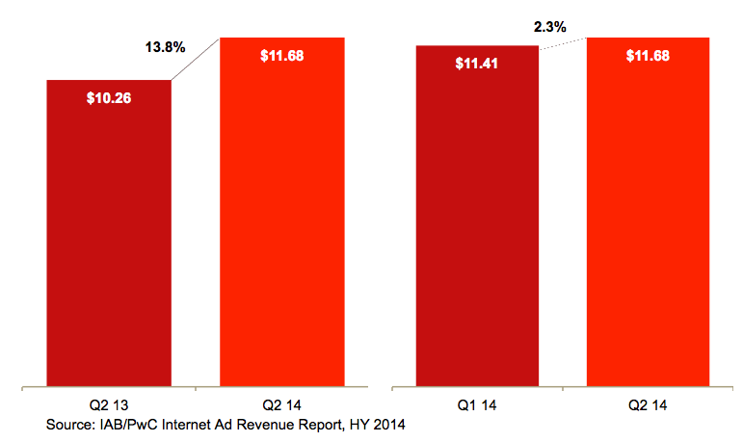

# Historical second-quarter revenue trends

## Strong revenue growth continues in Q2 2014

2014 second quarter revenues increased on a year-over-year basis. The 2014 second quarter was the highest second quarter on record, with the 13.8% year-over-year growth trailing the 10-year compound annual growth rate (CAGR) from 2005-2014 of 16.4%.

|  |
| --- |
| **Second-quarter revenue 2005-2014 ($ billions)** |

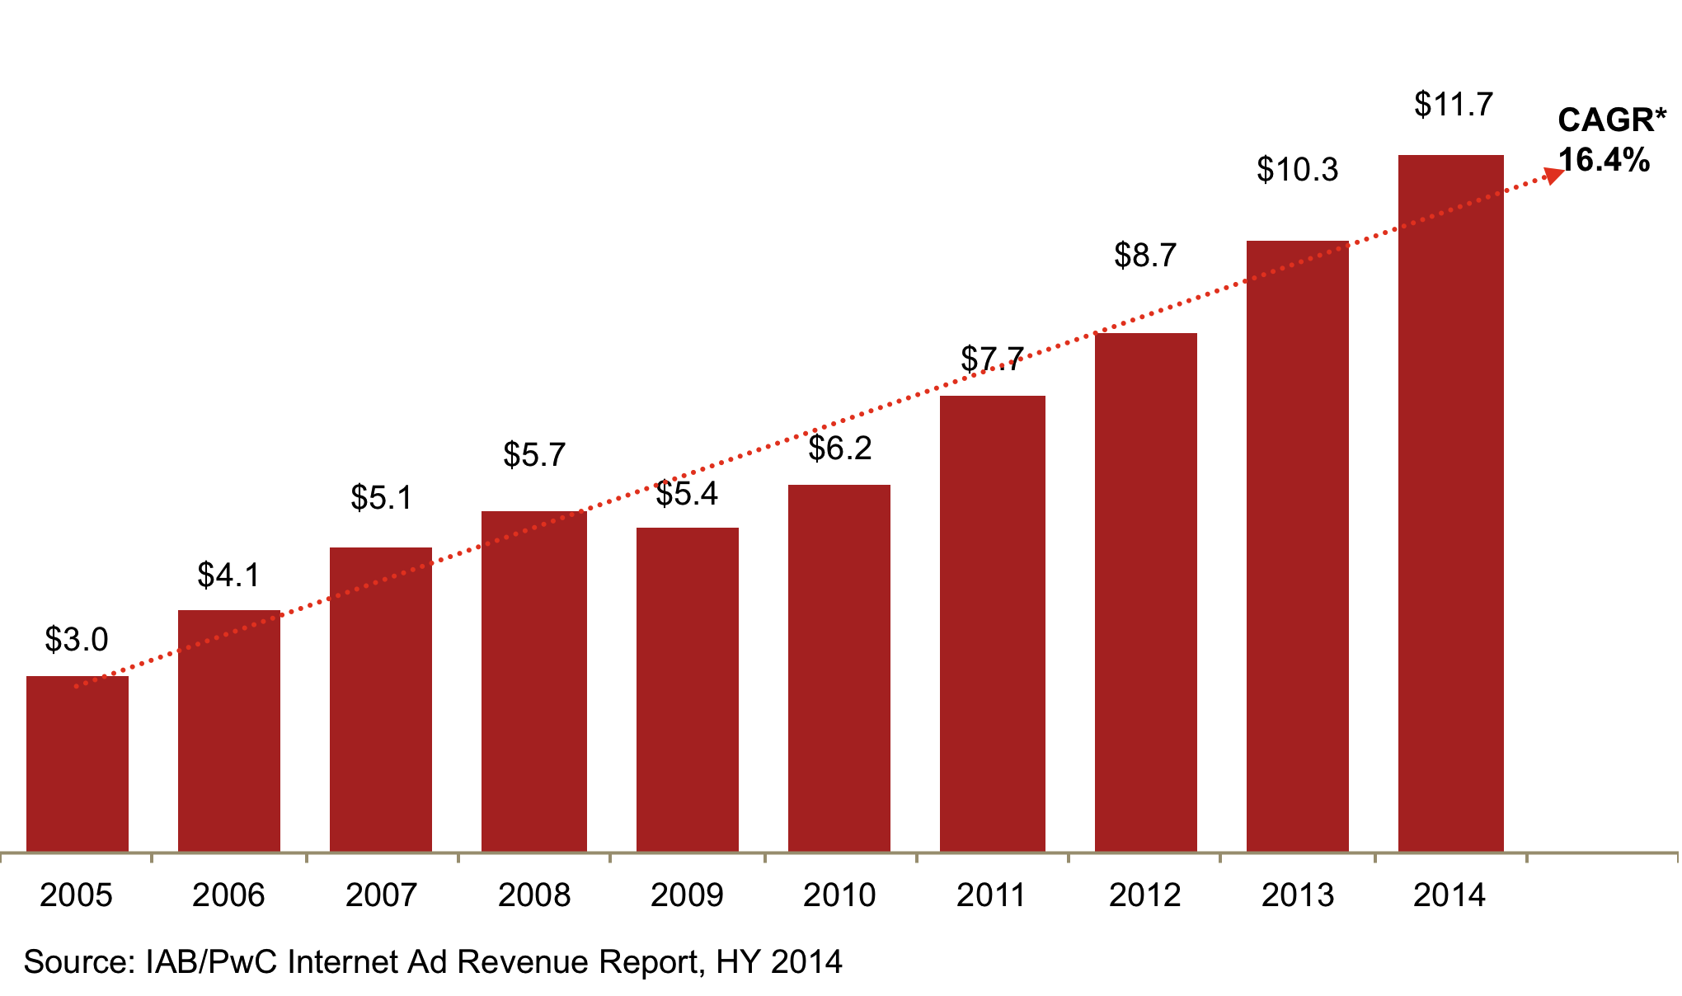

* CAGR: Compound Annual Growth Rate

# Historical quarterly revenue trends

## Quarterly growth continues upward trend

From the momentum built in 2010, internet advertising continues to show strong growth. After a seasonal dip in Q1 2014, Q2 2014 revenues continued the upward trend.

Since 2003, 78% of quarters (36 out of 46) have experienced positive growth over the prior quarter.

|  |
| --- |
| **Quarterly revenue growth trends 1996-2014 ($ billions)** |

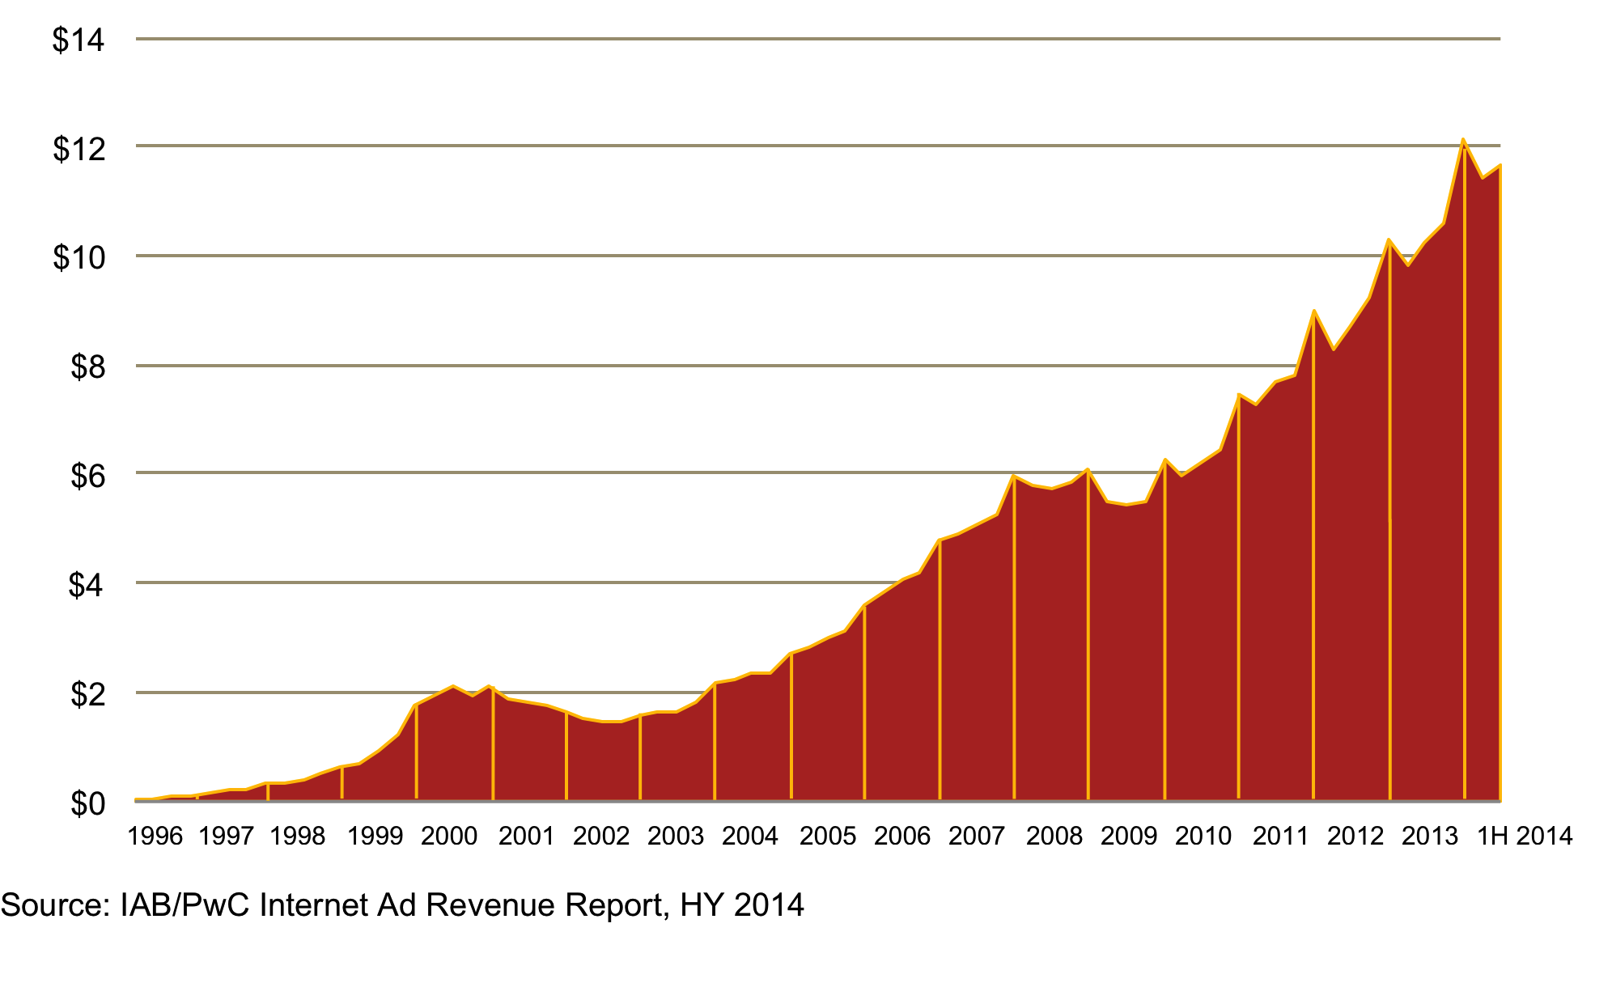

# Historical revenue mix – first half vs. second half

## First-half revenues reach $23.1 billion

Applying historical seasonal data, the 2014 first six months’ revenues of $23.1 billion are on an annual run-rate to make 2014 the highest year in revenues, on pace to exceed the previous highest annual total of $42.8 billion reported in 2013.

|  |
| --- |
| **Historical revenue mix, first half vs. second half ($ billions)** |

Over the past ten years, second half revenues averaged 53% of the annual total.

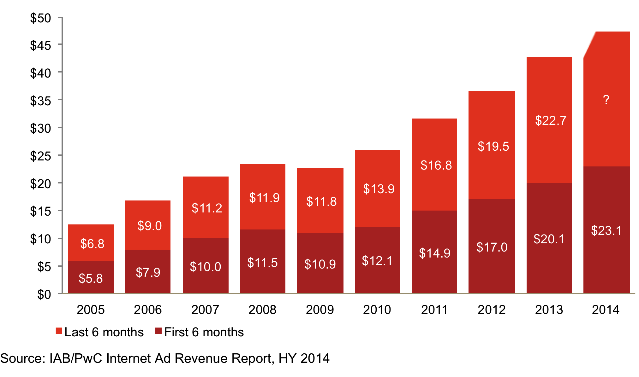

# Historical data findings

## Annual and quarterly revenue growth

|  | Revenue (in mil) | Q/Q Growth | Y/Y Growth |  |  | Revenue (in mil) | Q/Q Growth | Y/Y Growth |
| --- | --- | --- | --- | --- | --- | --- | --- | --- |
| Q1 2003 | $1,632 | 3% | 7% |  | Q1 2009 | $5,468 | -10% | -5% |
| Q2 2003 | $1,660 | 2% | 14% |  | Q2 2009 | $5,432 | -1% | -5% |
| Q3 2003 | $1,793 | 8% | 24% |  | Q3 2009 | $5,500 | 1% | -6% |
| Q4 2003 | $2,182 | 22% | 38% |  | Q4 2009 | $6,261 | 14% | 3% |
| **Total 2003** | **$7,267** |  | **21%** |  | **Total 2009** | **$22,661** |  | **-3%** |
| Q1 2004 | $2,230 | 2% | 37% |  | Q1 2010 | $5,942 | -5% | 9% |
| Q2 2004 | $2,369 | 6% | 43% |  | Q2 2010 | $6,185 | 4% | 14% |
| Q3 2004 | $2,333 | -2% | 30% |  | Q3 2010 | $6,465 | 5% | 18% |
| Q4 2004 | $2,694 | 15% | 24% |  | Q4 2010 | $7,449 | 15% | 19% |
| **Total 2004** | **$9,626** |  | **33%** |  | **Total 2010** | **$26,041** |  | **15%** |
| Q1 2005 | $2,802 | 4% | 25% |  | Q1 2011 | $7,264 | -2% | 22% |
| Q2 2005 | $2,985 | 7% | 26% |  | Q2 2011 | $7,678 | 6% | 24% |
| Q3 2005 | $3,147 | 5% | 35% |  | Q3 2011 | $7,824 | 2% | 21% |
| Q4 2005 | $3,608 | 15% | 34% |  | Q4 2011 | $8,970 | 15% | 20% |
| **Total 2005** | **$12,542** |  | **30%** |  | **Total 2011** | **$31,735** |  | **22%** |
| Q1 2006 | $3,848 | 7% | 37% |  | Q1 2012 | $8,307 | -7% | 14% |
| Q2 2006 | $4,061 | 6% | 36% |  | Q2 2012 | $8,722 | 5% | 14% |
| Q3 2006 | $4,186 | 3% | 33% |  | Q3 2012 | $9,236 | 6% | 18% |
| Q4 2006 | $4,784 | 14% | 33% |  | Q4 2012 | $10,307 | 12% | 15% |
| **Total 2006** | **$16,879** |  | **35%** |  | **Total 2012** | **$36,570** |  | **15%** |
| Q1 2007 | $4,899 | 2% | 27% |  | Q1 2013 | $9,806 | -5% | 18% |
| Q2 2007 | $5,094 | 4% | 25% |  | Q2 2013 | $10,260 | 5% | 18% |
| Q3 2007 | $5,267 | 3% | 26% |  | Q3 2013 | $10,609 | 3% | 15% |
| Q4 2007 | $5,946 | 13% | 24% |  | Q4 2013 | $12,106 | 14% | 17% |
| **Total 2007** | **$21,206** |  | **26%** |  | **Total 2013** | **$42,781** |  | **17%** |
| Q1 2008 | $5,765 | -3% | 18% |  | Q1 2014 | $11,414 | -6% | 16% |
| Q2 2008 | $5,745 | 0% | 13% |  | Q2 2014 | $11,678 | 2% | 14% |
| Q3 2008 | $5,838 | 2% | 11% |  |  |  |  |  |
| Q4 2008 | $6,100 | 4% | 2% |  |  |  |  |  |
| **Total 2008** | **$23,448** |  | **11%** |  |  |  |  |  |

# Revenue concentration

## Top 10 companies command 71% of revenues in Q2 2014

Online advertising remains concentrated with the ten leading ad-selling companies, accounting for 71% of total revenues in Q2 2014, up slightly from the 70% reported in Q2 2013. Companies ranked 11th to 25th accounted for 11% of revenues in Q2 2014, down slightly from the 12% reported in Q2 2013.

Despite the emergence of a few heavyweights in internet advertising publishing, the concentration of top-10 revenue has remained relatively unchanged over the past ten years, fluctuating between 69% and 74%.

|  |
| --- |
| **% share of total revenues** |

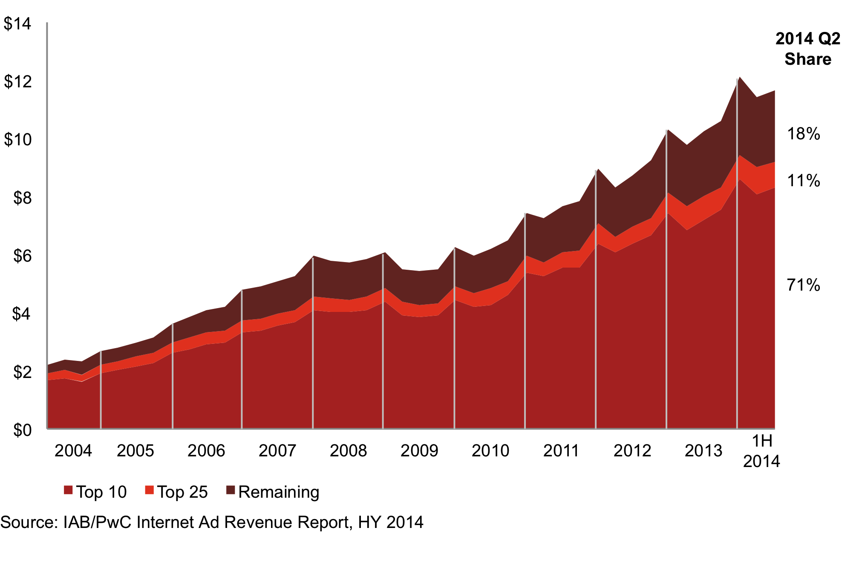

TOP 25

TOP 10

# Ad format – second quarter 2014 results

## Search continues to lead ad formats, while Mobile continues its steady growth

* Search accounted for $4.5 billion (38% of total) of Q2 2014 revenues, compared with $4.4 billion (43% of total) in Q2 2013. Inclusive of mobile-related search revenue, the Search format totaled $5.9 billion (51% of total) in Q2 2014 revenue.
* Display-related advertising accounted for $3.3 billion or 28% of total revenues during Q2 2014, up 5% from the $3.1 billion (30% of total) reported in Q2 2013. Q2 2014 Display-related advertising includes Banner Ads (17% of revenues, or $2.0 billion), Digital Video (7% or $760 million), Rich Media (3% or $355 million), and Sponsorship (2% or $187 million). Inclusive of mobile-related display revenue, the Display-related format totaled $4.6 billion (39% of total) in Q2 2014 revenue.
* Mobile revenues increased 71% from the $1.6 billion (16% of total) reported in Q2 2013 to $2.8 billion (24% of total) in Q2 2014, which consisted of $1.4 billion Mobile Search, $1.3 billion Mobile Display*, and $54 million Mobile Other.
* Classifieds revenues totaled $656 million or 6% of Q2 2014 revenues, up 2% from the $644 million (6% of total) reported in Q2 2013.
* Lead Generation revenues accounted for 4% of Q2 2014 revenues, or $463 million, up 5% from the $441 million (4% of total) reported in Q2 2013.

|  |  |  |
| --- | --- | --- |
| **Ad formats – Q2 2013** |  | **Ad formats – Q2 2014** |

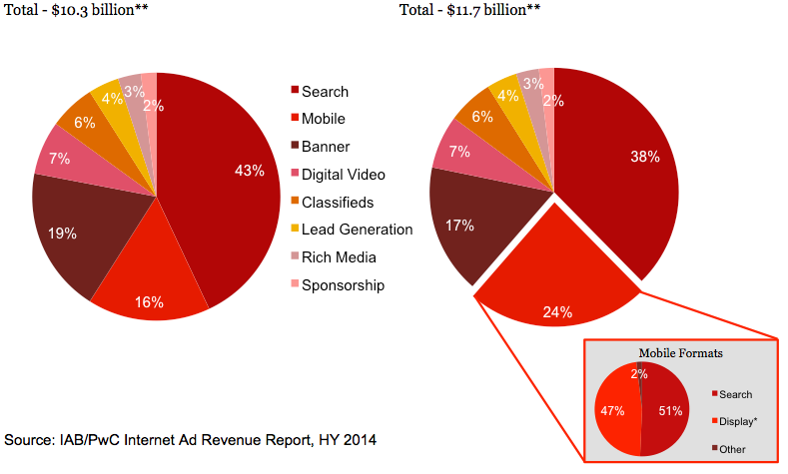

*\* Mobile Display includes: banner ads, digital video, digital audio, sponsorships, and rich media advertising served to mobile devices.  
** Amounts may not equal 100% due to rounding and omission of minor categories.*

# Ad format – first half 2014 results

***Mobile revenues in HY 2014 continue to increase format share, overtaking Banner ads***

* Search accounted for $9.1 billion (39% of total) of HY 2014 revenues, compared with $8.7 billion (43% of total) in HY 2013. Inclusive of mobile-related search revenue, the Search format totaled $11.8 billion (51% of total) in HY 2014 revenue.
* Display-related advertising accounted for $6.5 billion or 28% of total revenues during HY 2014, up 6% from the $6.1 billion (30% of total) reported in HY 2013. HY 2014 Display-related advertising includes Banner Ads (17% of HY 2014 revenues, or $3.9 billion), Digital Video (6% or $1.5 billion), Rich Media (3% or $694 million), and Sponsorship (2% or $366 million). Inclusive of mobile-related display revenue, the Display-related format totaled $9.0 billion (39% of total) in HY 2014 revenue.
* Mobile revenues increased 76% from the $3.0 billion (15% of total) reported at HY 2013 to $5.3 billion (23% of total) at HY 2014, which consisted of $2.7 billion Mobile Search, $2.5 billion Mobile Display*, and $103 million Mobile Other.
* Classifieds revenues totaled $1.3 billion or 6% of HY 2014 revenues, up 1% from the $1.3 billion (6% of total) reported in HY 2013.
* Lead Generation revenues accounted for 4% of HY 2013 revenues, or $911 million, up 7% from the $853 million (4% of total) reported in HY 2013.

|  |  |  |
| --- | --- | --- |
| **Ad formats – first half 2013** |  | **Ad formats – first half 2014** |

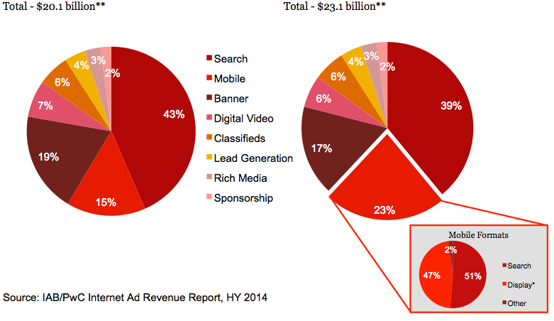

*\* Mobile Display includes: banner ads, digital video, digital audio, sponsorships, and rich media advertising served to mobile devices.*

*\*\* Amounts may not equal 100% due to rounding and omission of minor categories.*

# Historical format trends

## Search retains largest share of revenue, while Mobile overtakes Banner ads

* Search remains the leading format at 39% of HY 2014 revenues. Decline in its overall share is attributed to growth in Mobile and Mobile Search, which is included in the Mobile category.
* Search, Display, and Digital Video are all down slightly as a percentage of total revenue due to the substantial growth of Mobile. Classifieds, Lead Generation, and Rich Media remained consistent as a percentage of total revenue in comparison to HY 2013 results.
* Mobile revenues continued to quickly gain share, representing 23% of total HY 2014 revenues, as compared to 15% of total revenues reported in HY 2013 and 9% in HY 2012. While Mobile has eroded share of other formats, the Mobile format itself is comprised of multiple formats.

|  |
| --- |
| **Advertising format share, 2006 - 2014* (% of total revenue)** |

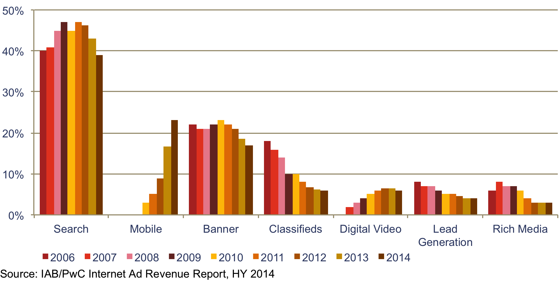* Format definitions may have changed over the time period depicted, both within the survey process and as interpreted by survey respondents.

# Social media advertising revenue

## Strong growth each half-year in social

For HY 2014, social media revenue was $2.9 billion. Social has experienced growth at each half-year since we first measured it in 2012. These steady increases are reflected in the 24.1% compound annual growth rate of social from HY 2012 to HY 2014.

*Note: We define social media as advertising delivered on social platforms, including social networking and social gaming websites and apps, across all device types, including desktop, laptop, smartphone and tablet.*

|  |
| --- |
| **Social media advertising revenue 2012-2014 ($ billions)** |

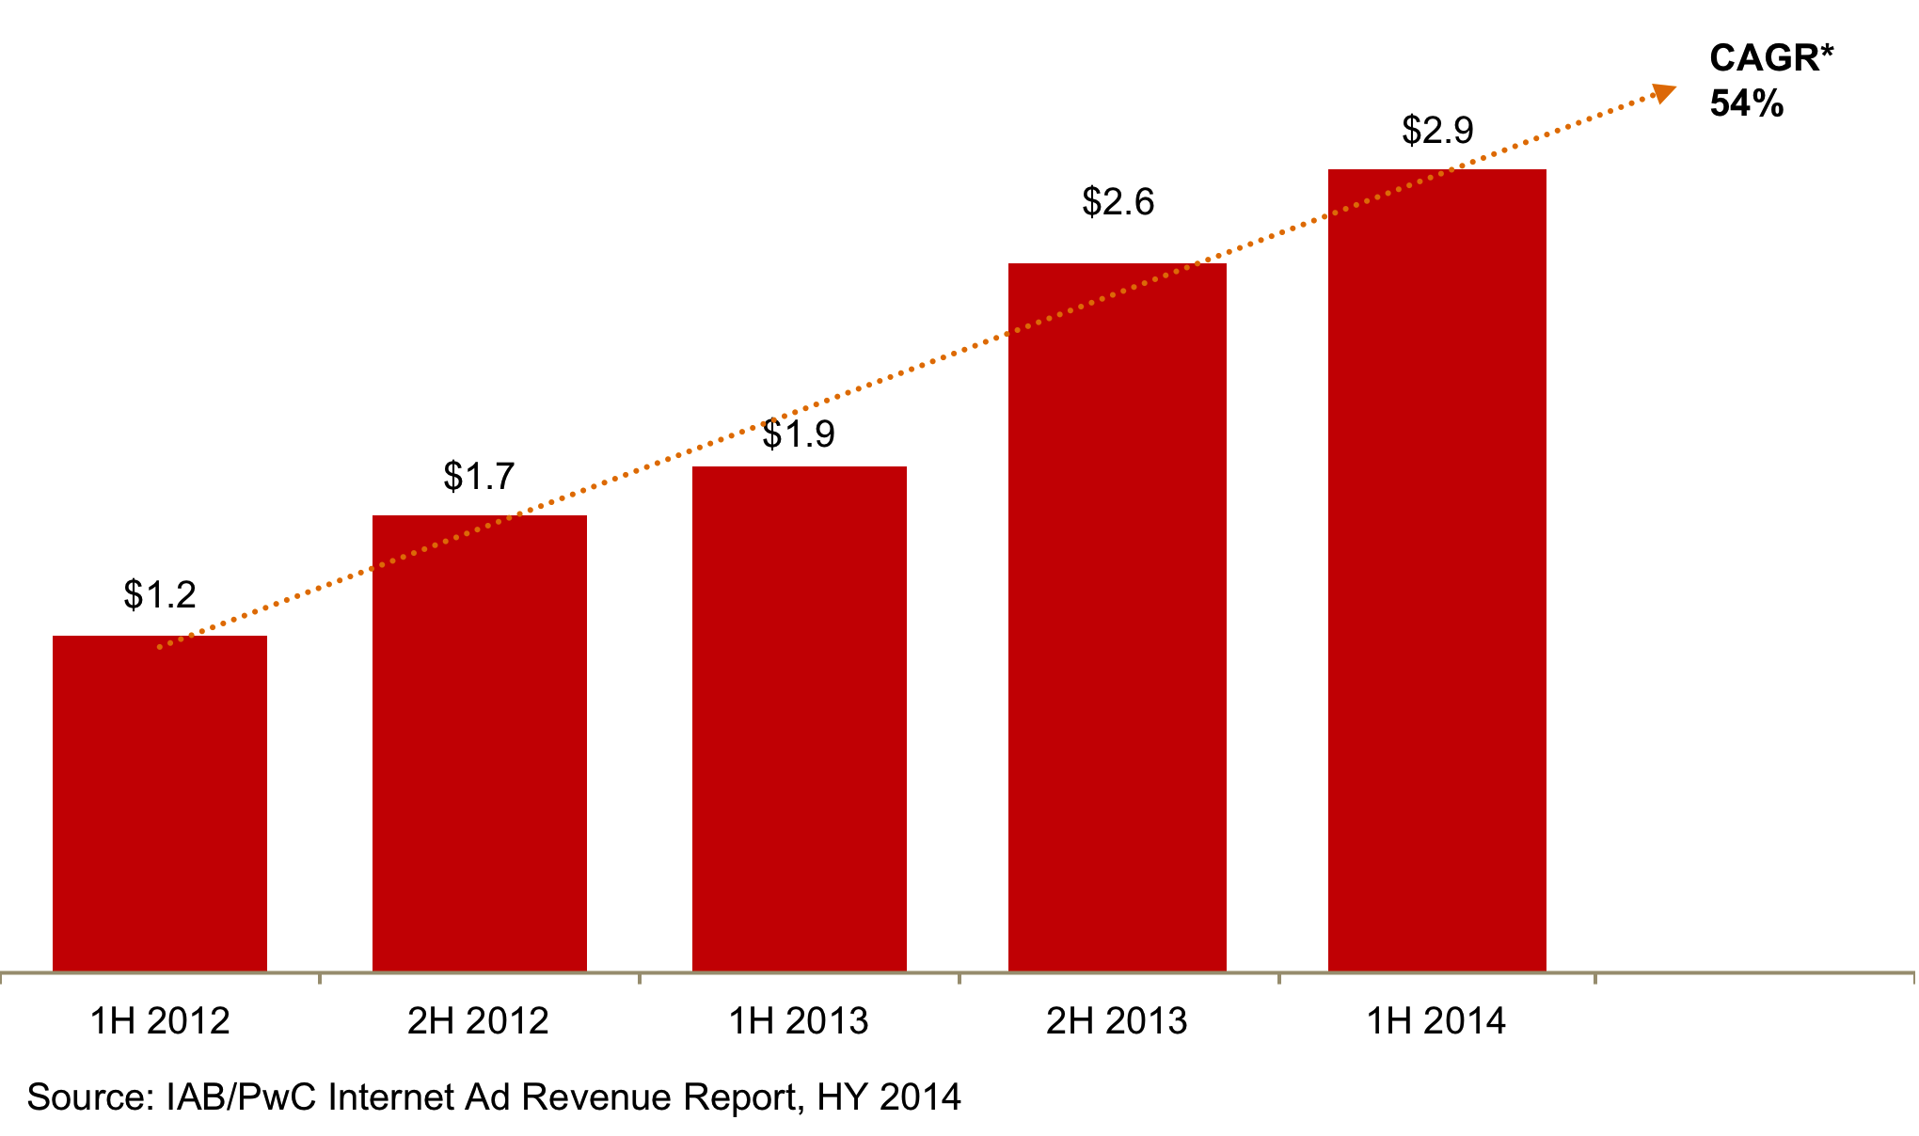

* CAGR: Compound Annual Growth Rate

# Ad revenues by industry category

## Retail drives advertising, as dollars shift to digital

* Retail advertisers continue to represent the largest category of internet ad spending, accounting for 21% of total revenues in HY 2014, consistent with the 21%reported in HY 2013.
* Financial Services advertisers accounted for 13 % of revenues in HY 2014, consistent with the 13% reported in HY 2013.
* Automotive advertisers accounted for 12 % of revenues in HY 2014, consistent with the 12% reported in HY 2013.
* Telecom companies accounted for 9% of revenues in HY 2014, consistent with the 9% reported in HY 2013.
* Leisure Travel (airfare, hotels, and resorts) accounted for 9% of revenues in HY 2014, up from the 8% reported in HY 2013.
* Consumer Packaged Goods represented 7% in HY 2014, consistent with the 7% reported in HY 2013.
* Consumer Electronics and Computers represented 7% of revenues in HY 2014, up from the 6% reported in HY 2013.
* Pharmaceutical/Healthcare accounted for 5% in HY 2014, consistent with the 5% reported in HY 2013.
* Media accounted for 5% in HY 2014, consistent with the 5% reported in HY 2013.
* Entertainment accounted for 4% of HY 2014 revenues, consistent with the 4% reported in HY 2013.

# Industry advertising – year-over-year comparison

|  |
| --- |
| **Internet ad revenues by major industry category*, year to date: 2013 vs. 2014** |

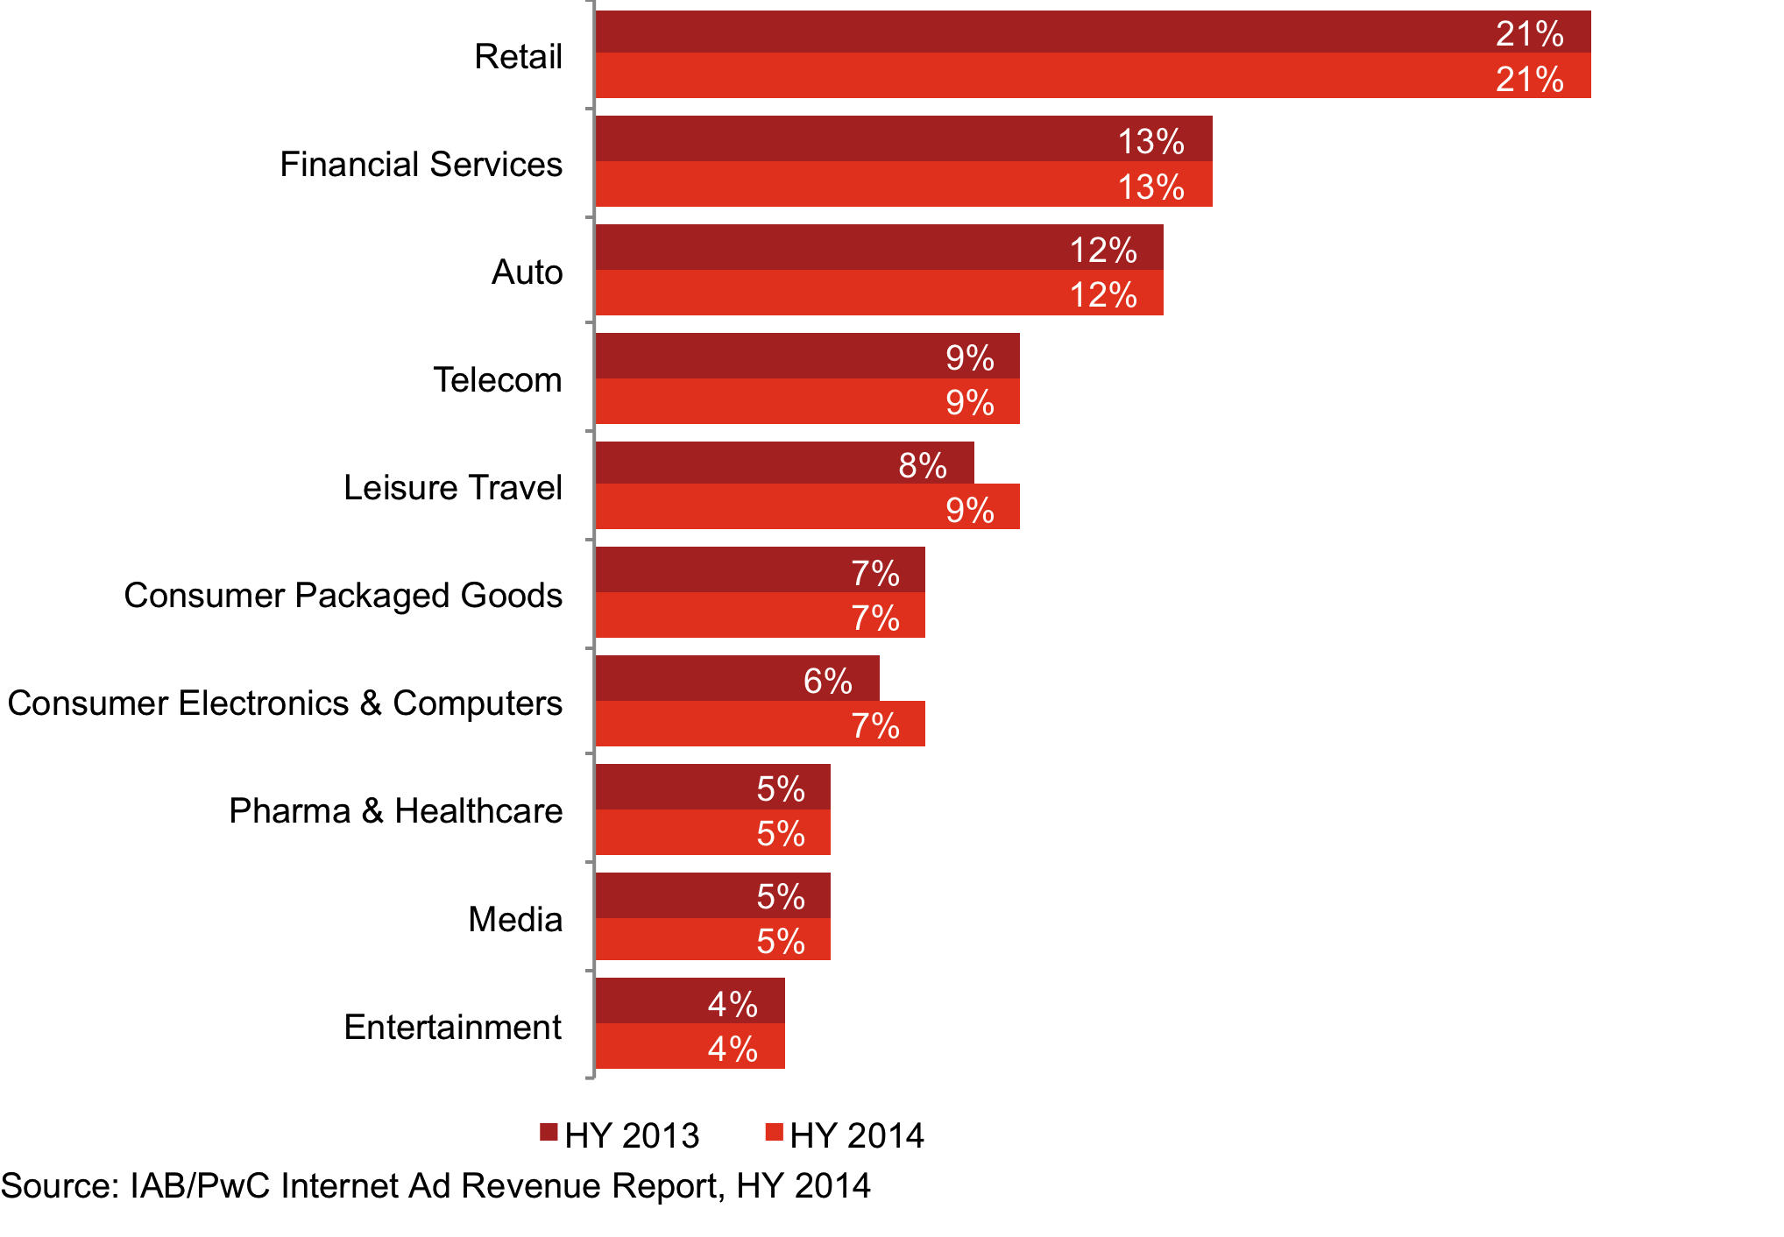* Industry category definitions may have changed over the time period depicted, both within the survey process and as interpreted by survey respondents. Amounts do not total to 100% as minor categories are not displayed.

# Revenues by pricing model

## CPM-based pricing shows slight uptick

* Approximately 65% of HY 2014 revenues were priced on a performance basis, consistent with the 65% reported in HY 2013.
* Approximately 34% of HY 2014 revenues were priced on a cost per medium/thousand (CPM) or impression basis, up from the 33% reported in HY 2013.
* Approximately 1% of HY 2014 revenues were priced on a hybrid basis, down from the 2% reported in HY 2013.

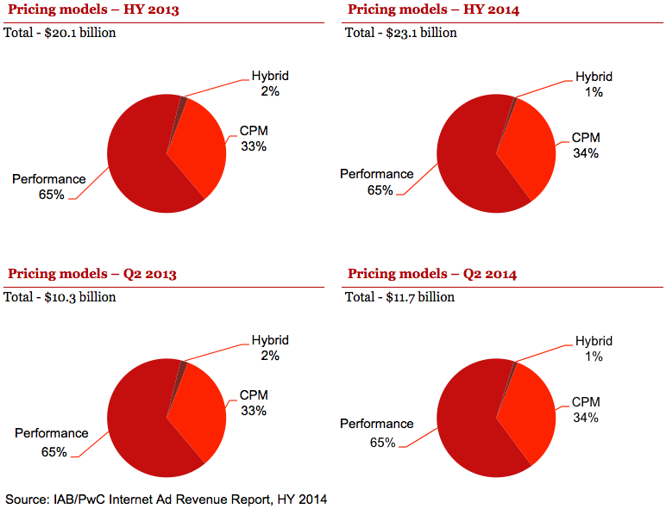

# Historical pricing model trends

## Performance-based pricing remains the preferred model

* Performance-based pricing, the leading pricing model since 2006, remained at 65% of total revenue in HY 2014.
* CPM/impression-based pricing gained in the first six months of 2014, up to 34% of revenues from 33% in HY 2013. At 34% of total revenues, CPM is at its highest point since 2010.
* Hybrid pricing decreased to 1% of total revenues in HY 2014, down from the 2% reported in HY 2013.

|  |
| --- |
| **Internet ad revenues by pricing model\*** |

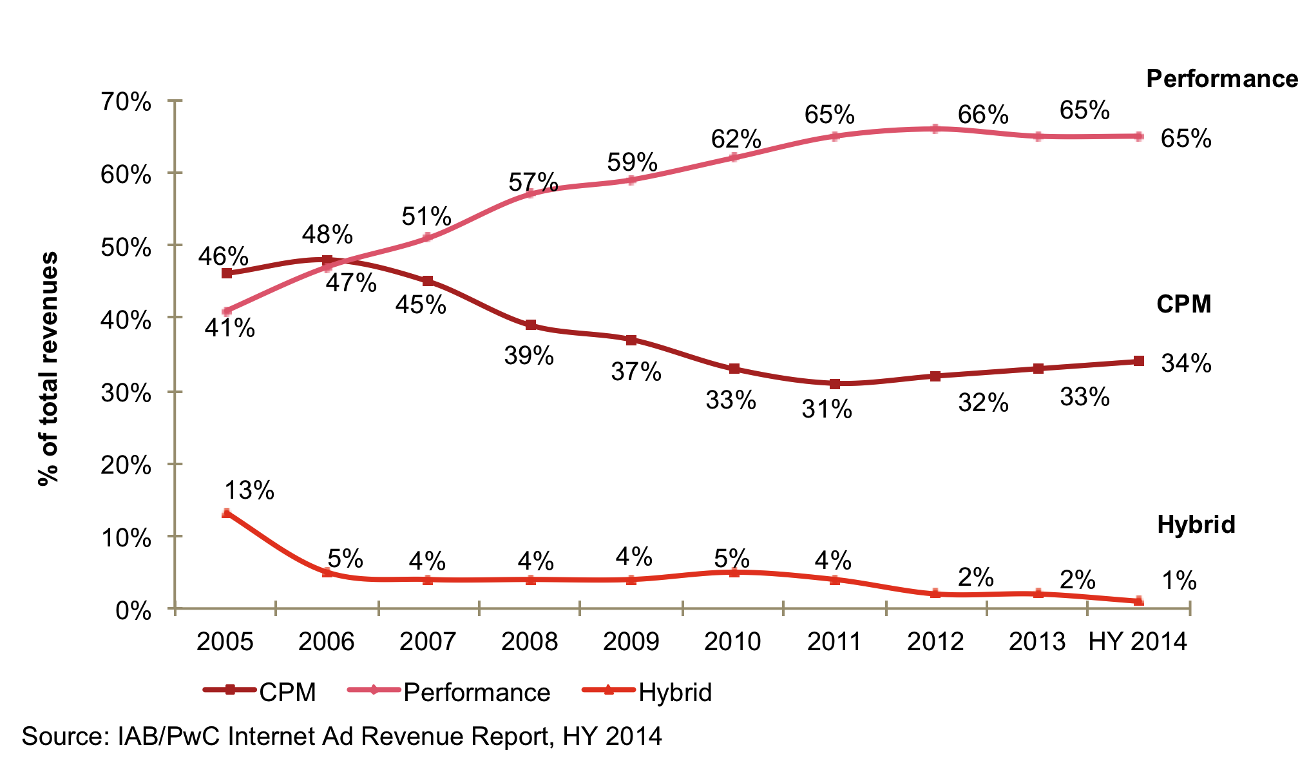* Pricing model definitions may have changed over the time period depicted both within the survey process and as interpreted by survey respondents.

# Appendix

## Definitions of leading industry categories

The industry categories used in the "IAB Internet Advertising Revenue Report" were sourced from the North American Standard Industrial Classification (SIC) Manual.†

|  |  |
| --- | --- |
| Retail | Includes mail order/catalog, apparel, restaurants/fast food, home furnishings/textiles, toys, pet food/supplies, appliances, jewelry, drugstores, retail stores, and cosmetics stores. |
| Automotive | Includes all automotive-related categories including sale/purchase of vehicles and parts and maintenance. |
| Entertainment | Includes film, music, TV, box office, video games, and amusement & recreation. |
| Consumer packaged goods | Includes packaged goods, food products, household products, and tobacco. |
| Leisure travel | Includes travel, hotel, airlines, and resorts. |
| Consumer Electronics and Computers | Includes hardware (computers, computer storage devices, and computer peripheral equipment), consumer electronics, prepackaged software (operating, utility, and applications programs), local area network systems and network systems integration, computer processing, and data preparation and data processing services. |
| Financial Services | Includes commercial banks, credit agencies, personal credit institutions, consumer finance companies, loan companies, business credit institutions, and credit card agencies. Also includes companies engaged in the underwriting, purchase, sale, or brokerage of securities and other financial contracts. |
| Telecommun-ications | Includes point-to-point communications services, including cellular phone services, paging services, wireless internet access, and wireless video services. Includes multichannel video providers on a subscription fee basis (e.g., cable television, wireless cable television, and direct broadcast satellite services). |
| Pharmaceutical & Healthcare | Includes pharmaceutical products, facilities, services, researchers, and biological products. Also comprises establishments providing healthcare and social assistance for individuals as well as personal care, toiletries, and cosmetic products. |
| Media | Includes establishments primarily engaged in radio and television broadcasting (network and station) including commercial, religious, educational, and other radio or television stations. Also includes establishments primarily engaged in publishing newspapers, periodicals, and books. |

†Survey participants reported results based on the 20 industry categories listed on page 25, which were used specifically for the "IAB Internet Advertising Revenue Report." This is consistent with other relevant industry categorization sources that measure advertising spending by industry. For purposes of this report, PwC classified a number of individual categories under “Retail.”

## Definitions of advertising formats

|  |  |
| --- | --- |
| Banner Advertising | Advertiser pays an online company for space on one or more of the online company’s pages to display a static or linked banner or logo. |
| Sponsorship | Advertiser pays for custom content and/or experiences, which may or may not include ad elements such as display advertising, brand logos, advertorial, or pre-roll video. Sponsorships fall into several categories:  Spotlights are custom-built pages incorporating an advertiser’s brand and housing a collection of content usually around a theme  Advergaming can range from an advertiser buying all the ad units around a game or a “sponsored by” link to creating a custom branded game experience  Content & Section Sponsorship is when an advertiser exclusively sponsors a particular section of the site or email (usually existing content) re-skinned with the advertiser’s branding  Sweepstakes & Contests can range from branded sweepstakes on the site to a full-fledged branded contest with submissions and judging |
| Email | Banner ads, links or advertiser sponsorships that appear in email newsletters, email marketing campaigns and other commercial email communications. This includes both ads within an email or the entire email. |
| Search | Fees advertisers pay online companies to list and/or link their company site domain name to a specific search word or phrase (includes paid search revenues). Search categories include:  Paid listings – payments made for clicks on text links that appear at the top or side of search results for specific keywords. The more a marketer pays, the higher the position it gets. Marketers only pay when a user clicks on the text link.  Contextual search – payments made for clicks on text links that appear in an article based on the context of the content, instead of a user-submitted keyword. Payment only occurs when the link is clicked.  Paid inclusion – payments made to guarantee that a marketer's URL is indexed by a search engine (i.e. advertiser isn’t paid only for clicks, as in paid listings).  Site optimization – payments made to optimize a site in order to improve the site’s ranking in search engine results pages (SERPs). (For example, site owner pays a company to tweak the site architecture and code, so that search engine algorithms will better index each page of the site). |
| Lead Generation | Fees paid by advertisers to online companies that refer qualified potential customers (e.g., auto dealers which pay a fee in exchange for receiving a qualified purchase inquiry online) or provide consumer information (demographic, contact, behavioral) where the consumer opts in to being contacted by a marketer (email, postal, telephone, fax). These processes are priced on a performance basis (e.g., cost-per-action, -lead or -inquiry), and can include user applications (e.g., for a credit card), surveys, contests (e.g., sweepstakes) or registrations. |
| Classifieds and Auctions | Fees paid to advertisers by online companies to list specific products or services (e.g., online job boards and employment listings, real estate listings, automotive listings, auction-based listings, yellow pages). |
| Rich Media | Display-related ads that integrate some component of streaming interactivity. Rich media ads often include flash or java script, but not content, and can allow users to view and interact with products or services (e.g., scrolling or clicking within the ad opens a multimedia product description, expansion, animation, video or a “virtual test-drive” within the ad).  All IAB Rising Stars ad formats are considered Rich Media. Video commercials that appear in video players are considered Digital Video Ads, not Rich Media.  “Interstitials” have been consolidated within the rich media category and represent full- or partial-page text and image server-push advertisements which appear in the transition between two pages of content. Forms of interstitials can include a variation of the following terms:  Splash screens – a preliminary page that precedes the regular home page of a website that usually promotes a particular site feature or provides advertising. A splash page is timed to move onto the home page after a short period of time.  Pop-up ads and pop-under ads – an advertisement that appear in a separate window which automatically loads over an existing content window, without an associated banner.  Daughter windows – an advertisement that runs in a separate window associated with a concurrently displayed banner. The content and banner are typically displayed first, followed by the daughter window.  Superstitials – ads that are distinct from interstitials because of the much higher ad quality, and that they play instantly (ads are fully downloaded before they are displayed). |

## Definitions of advertising formats (cont.)

|  |  |
| --- | --- |
| Digital Video Advertising | Advertising that appears before, during or after digital video content in a video player (i.e. pre-roll, mid-roll, post-roll video ads). Digital Video Ads include TV commercials online and can appear in streaming content or in downloadable video. Display-related ads on a page (that are not in a player) that contain video are categorized as rich media ads.  Video Overlays are also categorized as Digital Video Advertising. Video overlays include small ads that appear on top of digital video content. They can appear to be display, video, rich media, text or another ad format but are contained within the video player. |
| Mobile Advertising | Advertising tailored to and delivered through wireless mobile devices such as smartphones (e.g. Blackberry, iPhone, Android, etc.), feature phones (e.g. lower-end mobile phones capable of accessing mobile content), and media tablets (e.g. iPad, Samsung Galaxy Tablet, etc.). Typically taking the form of static or rich media display ads, text messaging ads, search ads, or audio/video spots, such advertising generally appears within mobile websites (e.g. websites optimized for viewing on mobile devices), mobile apps (e.g. applications for Smartphones running iOS, Android, Windows Mobile or other operating systems), text messaging services (i.e. SMS, MMS) or within mobile search results (i.e., 411 listings, directories, mobile-optimized search engines).  Mobile advertising formats include: Search, Display (banner ads, digital video, digital audio, sponsorships, and rich media), and Other advertising served to mobile devices. |
| Digital Audio | Refers to partially or entirely advertising-supported audio programming available to consumers on a streaming basis, delivered via the wired and mobile Internet. This includes a wide range of services, such as the following:  Online audio streams of terrestrial radio stations;  Purely online radio stations, with either professional or amateur DJs;  Personalized (i.e., without human editors/DJs) and on-demand, streamed audio services that create playlists based on user preferences of artists, tracks, or genres;  Music or spoken word audio content delivered within a different website or application, e.g., in-game music services. |
| Social Media Advertising | Advertising delivered on social platforms, including social networking and social gaming websites and apps, across all device types, including desktop, laptop, smartphone and tablet. |

## Survey scope and methodology

### Survey scope

The Interactive Advertising Bureau (IAB) retained PwC to establish a comprehensive standard for measuring the growth of internet/online/mobile advertising revenues. The "IAB internet advertising revenue report" is part of an ongoing IAB mission to provide an accurate barometer of internet advertising growth.

To achieve differentiation from existing estimates and accomplish industry-wide acceptance, key aspects of the survey include:

* Obtaining historical data directly from companies generating internet/online/mobile advertising revenues;
* Making the survey as inclusive as possible, encompassing all forms of internet/online/mobile advertising, including websites, consumer online services, ad networks, mobile devices, and email providers; and
* Ensuring and maintaining a confidential process, releasing only aggregate data.

### Methodology

PwC performs the following:

* Compiles a database of industry participants selling internet/online and mobile advertising revenues
* Conducts a quantitative mailing survey with leading industry players, including Web publishers, ad networks, commercial online service providers, mobile providers, email providers, and other online media companies
* Acquires supplemental data through the use of publicly disclosed information
* Requests and compiles several specific data items, including monthly gross commissionable advertising revenue by industry category and transaction
* Identifies non-participating companies and applies a conservative revenue estimate based on available public sources
* Analyzes the findings, identifies and reports key trends

## Survey industry categories

|  |  |  |
| --- | --- | --- |
| Automotive  Beer/Wine/Liquor  Business Products/Services  Computers (Hardware/Software) and Consumer Electronics  Consumer Packaged Goods, Food, Non-Alcoholic Beverages and Candy  Educational Services  Entertainment (Film, Music, TV, Box Office, Video Games, Amusement/Recreational) | Financial Services (Banks, Insurance, Securities, Mortgages)  Personal Care, Toiletries, and Cosmetics  Drugs and Remedies  Manufacturing  Media  Professional Sports and Sporting & Athletic Goods  Real Estate | Restaurants/Fast Food  Retail, Mail Order, Catalogs and Apparel  Telecommunications: Telephony, Cable/Satellite TV Services, ISPs  Toys/Games  Leisure Travel (Airfare, Hotels, Resorts)  Business Travel (Airfare, Hotels, Resorts) |

## About the Interactive Advertising Bureau

The Interactive Advertising Bureau (IAB) empowers the media and marketing industries to thrive in the digital economy. It is comprised of more than 650 leading media and technology companies that are responsible for selling, distributing and optimizing digital advertising and marketing. Together, they account for 86 percent of online advertising in the United States. Working with its member companies, the IAB evaluates and recommends standards and practices and fields critical research on interactive advertising. The organization is committed to professional development, elevating the knowledge, skills, and expertise of individuals across the digital marketing industry. The IAB also educates marketers, agencies, media companies and the wider business community about the value of interactive advertising. Founded in 1996, the IAB is headquartered in New York City.

## Overall report guidance provided by IAB leadership

|  |  |  |
| --- | --- | --- |
| Executive Committee | | |
| President and CEO  **Randall Rothenberg** IAB  **Denise Warren**  The New York Times Company  **Randy Kilgore**  Tremor Media | Chairman  **Vivek Shah**  Ziff Davis  **Neal Mohan**  Google  **David Moore**  Xaxis | Vice Chair  **David Morris**  CBS Interactive  **Bill Todd**  Conversant Media  **Lisa Utzschneider**  Amazon.com  **Rik van der Kooi** Microsoft Advertising |

|  |  |  |
| --- | --- | --- |
| Ex-Officio | | |
| Founding Chairman  **Rich LeFurgy** Archer Advisors | Treasurer  **John Toohey**  Time Warner Cable Media | **Joe Rosenbaum** Reed Smith LLP |

|  |  |  |
| --- | --- | --- |
| Board of Directors | | |
| **Joe Apprendi** Collective  **David Brinker**  News Corporation  **Ned Brody**  Yahoo!  **Kevin Conroy** Univision  **Jory Des Jardins**  BlogHer  **Mark Ford**  Time Inc.  **Eric Franchi**  Undertone  **Michael Friedenberg**  IDG  **Joan Gillman** Time Warner Cable Media | **Curt Hecht**  The Weather Channel  **Mark Howard**  Forbes.com  **Eric Johnson**  ESPN.com  **Neil O. Johnston**  CMG Digital  **Seth Ladetsky**  Turner Broadcasting System  **David Lawenda**  Facebook  **Jean-Philippe Maheu**  Twitter  **Suzanne McDonnell**  Discovery Communications  **Jim Norton**  AOL | **Scott Schiller**  NBC Universal Digital Media  **Drew Schutte**  Condé Nast  **Tad Smith**  Cablevision Systems Corporation  **John Trimble**  Pandora  **Jacob Weisberg**  Slate  **Mike Welch**  AT&T AdWorks  **Troy Young**  Hearst Magazines Digital Media  **Penry Price**  LinkedIn |

## PwC New Media Group with the Entertainment, Media, and Communications practice

As business, accounting, and tax advisors to many of the world’s leading Entertainment, Media, and Communications (EMC) and Technology (Tech) companies, PwC (www.pwc.com) has an insider’s view of trends and developments driving the industry. With approximately 1,200 practitioners serving EMC and Tech clients in the United States, PwC is deeply committed to providing clients with industry expertise and resources. In recent years, our pioneering work in EMC and Tech has included developing strategies to leverage digital technology, identifying new sources of financing, and marketplace positioning in industries characterized by consolidation and transformation. Our experience reaches across all geographies and segments of the EMC and Tech sectors, including broadband, wireless, the internet, music, film, television, publishing, advertising, gaming, theme parks, computers and networking, and software. With thousands of practitioners around the world, we're always close at hand to provide deep industry knowledge and resources.

PwC’s New Media Group was the first practice of its kind at a Big Four firm. Currently located in New York, Los Angeles, Boston, Seattle, and the Bay Area, our New Media Group includes accounting, tax, and consulting professionals who have broad and deep experience in the three areas that converge to form new media: advanced telecommunications, enabling software, and content development/distribution.

**Our services include:**

* Business assurance services
* Web audience measurement and advertising delivery auditing and advisory
* IAB Measurement Certification Compliance auditing
* Privacy policy structuring, attestation, and compliance advisory
* Mergers & acquisitions assistance
* Tax planning and compliance
* Capital sourcing and IPO assistance

For more information about our New Media Group, contact one of the following PwC professionals:

|  |  |  |
| --- | --- | --- |
| New York  **David Silverman**  Partner, Assurance Services  646.471.5421  [***david.silverman@us.pwc.com***](mailto:david.silverman@us.pwc.com) | New York  **Russ Sapienza**  Partner, Advisory Services  646.471.1517  [***russell.j.sapienza@us.pwc.com***](mailto:russell.j.sapienza@us.pwc.com) | New York  **Michael Altschul**  Director, Advisory Services  646.471.4903  [***michael.altschul@us.pwc.com***](mailto:michael.altschul@us.pwc.com) |
|  |  |  |
| Boston  **Vic Petri**  Partner, Assurance Services  617.478.1698  [***victor.petri@us.pwc.com***](mailto:victor.petri@us.pwc.com) | San Jose  **Mike Pearl**  Partner, Assurance Services  408.817.3801  [***michael.pearl@us.pwc.com***](mailto:michael.pearl@us.pwc.com) | Seattle  **Suzanne Faulkner**  Partner, Assurance Services  206.398.3550  [***suzanne.faulkner@us.pwc.com***](mailto:suzanne.faulkner@us.pwc.com) |

www.pwc.com/e&m