

***IAB internet advertising  
revenue report***

2013 full year results

April 2014

An industry survey conducted by PwC and sponsored by the Interactive Advertising Bureau (IAB)

[www.pwc.com](mailto:www.pwc.com)  
[www.iab.net](mailto::www.iab.net)

Table of Contents

Background 3

Executive summary 4

Detailed findings 6

Historical trends 7

Ad formats 12

Industries 15

Pricing models 17

Advertising market share 19

Appendix 22

# Background

## About the IAB internet advertising revenue report

Conducted by PricewaterhouseCoopers LLP (“PwC”) on an ongoing basis, with results released quarterly, the “IAB Internet Advertising Revenue Report” was initiated by the Interactive Advertising Bureau (IAB) in 1996. This report utilizes data and information reported directly to PwC, publicly available online corporate data, and information provided by online ad selling companies.

The results reported are considered the most accurate measurement of internet/online/mobile advertising revenues because much of the data is compiled directly from information supplied by companies selling advertising online. All-inclusive, the report includes data reflecting online advertising revenues from websites, commercial online services, ad networks and exchanges, mobile devices, and e-mail providers, as well as other companies selling online advertising.

The report is conducted independently by PwC on behalf of the IAB. PwC does not audit the information and provides no opinion or other form of assurance with respect to the information. Only aggregate results are published and individual company information is held in strict confidence with PwC. Further details regarding scope and methodology are provided in the appendix to this report.

David Silverman  
PwC

# Executive summary

## 'IAB internet advertising revenue report' 2013 full year highlights

Internet advertising revenues (“revenues”) in the United States totaled $42.8 billion for the full year of 2013, with Q4 2013 accounting for approximately $12.1 billion and Q3 2013 accounting for approximately $10.6 billion. Revenues for the full year of 2013 increased 17% over 2012.

**Key trends underlying 2013 results**

|  |
| --- |
| **Revenues increase 17% in FY 2013** — Internet advertising revenues in the United States totaled $12.1 billion in the fourth quarter of 2013, an increase of 14% from the 2013 third-quarter total of $10.6 billion and an increase of 17% from the 2012 fourth-quarter total of $10.3 billion. 2013 full year internet advertising revenues totaled $42.78 billion, up 17% from the $36.57 billion reported in 2012.  *“The news that interactive has outperformed broadcast television should come as no surprise. It speaks to the power that digital screens have in reaching and engaging audiences. In that same vein, the triple-digit growth of mobile is clearly a direct response to how smaller digital screens play an integral role in consumers' lives throughout the day, as well as their critical importance to cross-screen experiences.”*  — Randall Rothenberg, President and CEO, IAB |
| **Mobile advertising increases 110% in FY 2013** — Mobile advertising in the United States totaled $7.1 billion during FY 2013, a 110% increase from the prior year total of $3.4 billion.  *“Our survey confirms that we are fully in transition to the post-desktop era. Triple-digit advertising revenue growth from mobile devices contrasted the more tepid 8% growth from traditional computer screens. This is simply a reflection of the change in how and where consumers are viewing their information -- on the go!”*  — David Silverman, Partner, PwC |

# Annual revenues show strong growth

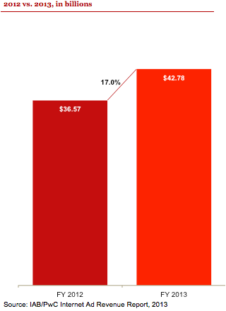

## Annual revenues for 2013 totaled $42.8 billion, $6.2 billion (or 17.0%) higher than in 2012.

# Detailed findings

***Revenues total a record $12.1 billion in Q4 2013***

Total 2013 fourth quarter revenues broke the prior quarter record of $10.6 billion set in the third quarter of 2013 by $1.5 billion. Fourth quarter 2013 revenues were $1.8 billion (17.5%) higher than in the fourth quarter of 2012.

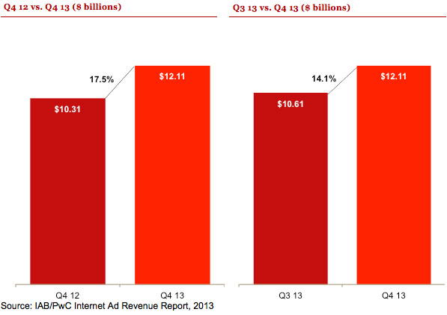

# Historical annual revenue trends

## Revenue continues strong growth in 2013

2013 annual revenues increased on a year-over-year percentage and dollar basis. The compound annual growth rate (CAGR) over the past ten years for internet advertising of 18% has outpaced U.S. current dollar GDP growth of 4%* over that period.

Since 2010, internet advertising growth was fueled by a 123% CAGR in Mobile (compared to 12% growth in non-Mobile revenue).

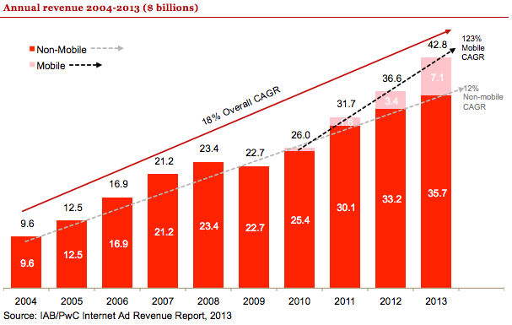

* Source for GDP growth: U.S. Bureau of Economic Analysis, “[Table 1.1.5. Gross Domestic Product](http://www.bea.gov/iTable/iTableHtml.cfm?reqid=9&step=3&isuri=1&910=x&911=0&903=5&904=2004&905=2013&906=a),” (accessed March 31, 2013)

# Historical quarterly revenue trends

## Quarterly growth continues upward trend

Internet advertising continued to build on the momentum from 2012.

Over the past four years we have seen a clear seasonal trend of strong fourth quarter revenue followed by a first quarter dip. Despite the seasonal dip, first quarter revenues have outpaced the prior year's third quarter since 2010.

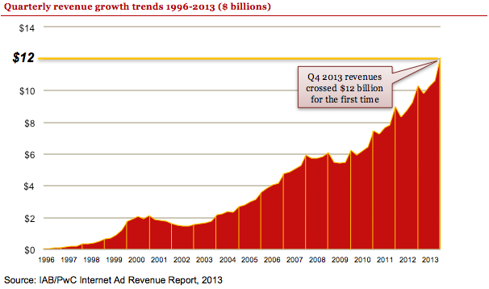

# Historical revenue mix – first half vs. second half

## Second-half revenues reach $22.7 billion

Second-half revenues totaled $22.7 billion in 2013, an increase of $3.2 billion from second-half revenues of 2012, which totaled $19.5 billion. Second-half revenues in 2013 represented 53% of total revenues in 2013, consistent with numbers reported in 2012 and consistent with the broader trend of higher revenues in the second-half of each year. The historically higher proportion of revenues in the second half of the year results from both the continued growth in the industry and from the seasonality of higher ad spend in the fourth quarter.

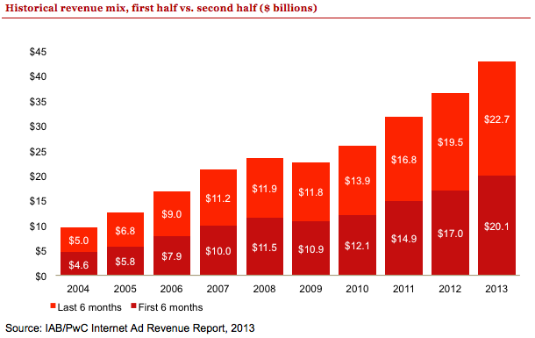

# Historical data findings

## Annual and quarterly revenue growth

|  | Revenue (in mil) | Q/Q Growth | Y/Y Growth |  |  | Revenue (in mil) | Q/Q Growth | Y/Y Growth |
| --- | --- | --- | --- | --- | --- | --- | --- | --- |
| Q1 2002 | $1,520 | -7% | -19% |  | Q1 2008 | $5,765 | -3% | 18% |
| Q2 2002 | $1,458 | -4% | -21% |  | Q2 2008 | $5,745 | 0% | 13% |
| Q3 2002 | $1,452 | -1% | -18% |  | Q3 2008 | $5,838 | 2% | 11% |
| Q4 2002 | $1,580 | 9% | -4% |  | Q4 2008 | $6,100 | 4% | 2% |
| **Total 2002** | **$6,010** |  | **-16%** |  | **Total 2008** | **$23,448** |  | **11%** |
| Q1 2003 | $1,632 | 3% | 7% |  | Q1 2009 | $5,468 | -10% | -5% |
| Q2 2003 | $1,660 | 2% | 14% |  | Q2 2009 | $5,432 | -1% | -5% |
| Q3 2003 | $1,793 | 8% | 24% |  | Q3 2009 | $5,500 | 1% | -6% |
| Q4 2003 | $2,182 | 22% | 38% |  | Q4 2009 | $6,261 | 14% | 3% |
| **Total 2003** | **$7,267** |  | **21%** |  | **Total 2009** | **$22,661** |  | **-3%** |
| Q1 2004 | $2,230 | 2% | 37% |  | Q1 2010 | $5,942 | -5% | 9% |
| Q2 2004 | $2,369 | 6% | 43% |  | Q2 2010 | $6,185 | 4% | 14% |
| Q3 2004 | $2,333 | -2% | 30% |  | Q3 2010 | $6,465 | 5% | 18% |
| Q4 2004 | $2,694 | 15% | 24% |  | Q4 2010 | $7,449 | 15% | 19% |
| **Total 2004** | **$9,626** |  | **33%** |  | **Total 2010** | **$26,041** |  | **15%** |
| Q1 2005 | $2,802 | 4% | 25% |  | Q1 2011 | $7,264 | -2% | 22% |
| Q2 2005 | $2,985 | 7% | 26% |  | Q2 2011 | $7,678 | 6% | 24% |
| Q3 2005 | $3,147 | 5% | 35% |  | Q3 2011 | $7,824 | 2% | 21% |
| Q4 2005 | $3,608 | 15% | 34% |  | Q4 2011 | $8,970 | 15% | 20% |
| **Total 2005** | **$12,542** |  | **30%** |  | **Total 2011** | **$31,735** |  | **22%** |
| Q1 2006 | $3,848 | 7% | 37% |  | Q1 2012 | $8,307 | -7% | 14% |
| Q2 2006 | $4,061 | 6% | 36% |  | Q2 2012 | $8,722 | 5% | 14% |
| Q3 2006 | $4,186 | 3% | 33% |  | Q3 2012 | $9,236 | 6% | 18% |
| Q4 2006 | $4,784 | 14% | 33% |  | Q4 2012 | $10,307 | 12% | 15% |
| **Total 2006** | **$16,879** |  | **35%** |  | **Total 2012** | **$36,570** |  | **15%** |
| Q1 2007 | $4,899 | 2% | 27% |  | Q1 2013 | $9,806 | -5% | 18% |
| Q2 2007 | $5,094 | 4% | 25% |  | Q2 2013 | $10,260 | 5% | 18% |
| Q3 2007 | $5,267 | 3% | 26% |  | Q3 2013 | $10,609 | 3% | 15% |
| Q4 2007 | $5,946 | 13% | 24% |  | Q4 2013 | $12,106 | 14% | 17% |
| **Total 2007** | **$21,206** |  | **26%** |  | **Total 2013** | **$42,781** |  | **17%** |

# Revenue concentration

## Top 10 companies command 71% of revenues in Q4 2013

Online advertising continues to remain concentrated with the 10 leading ad-selling companies, which accounted for 71% of total revenues in Q4 2013, down slightly from the 72% reported in Q4 2012. Companies ranked 11th to 25th accounted for 10% of revenues in Q4 2013, consistent with the 10% reported in Q4 2012.

Despite the emergence of a few heavyweights in internet advertising publishing, the concentration of top-10 revenue has remained relatively unchanged over the past ten years, fluctuating between 69% and 74%.

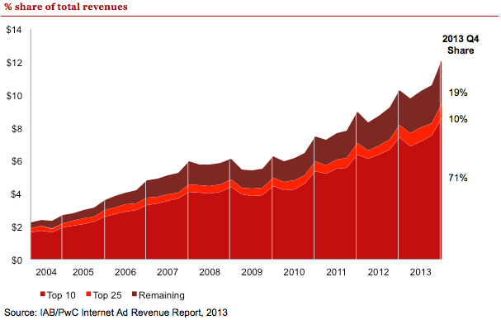

TOP 25

TOP 10

2012

2005

2004

2013

2011

2010

2009

2008

2007

2006

# Ad format – fourth quarter 2013 results

## Search continues to lead ad formats, while Mobile eclipses Display for the first time in a quarter

* Search accounted for 41% of Q4 2013 revenues, down from 44% in Q4 2012, as mobile devices have shifted Search-related revenues away from the desktop computer. Search revenues totaled $5.0 billion in Q4 2013, up 10% from Q4 2012, when Search totaled $4.6 billion.
* Display-related advertising accounted for $3.7 billion or 30% of total revenues during Q4 2013, up 6% from the $3.4 billion (33% of total) reported in Q4 2012. Q4 2013 Display-related advertising includes Display/Banner Ads (19% of revenues, or $2.3 billion), Digital Video (7% or $807 million), Rich Media (3% or $364 million), and Sponsorship (2% or $227 million).
* Mobile revenues totaled 19% of Q4 2013 revenues, or $2.3 billion, up 92% from the $1.2 billion (11% of total) reported in Q4 2012.
* Classifieds revenues totaled $664 million or 5% of Q4 2013 revenues, up 2% from the $651 million (6% of total) reported in Q4 2012.
* Lead Generation revenues accounted for 4% of Q4 2013 revenues, or $484 million, up 9% from the $446 million (4% of total) reported in Q4 2012.

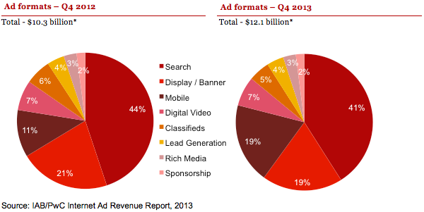

* Amounts may not equal 100% due to rounding and omission of minor categories.

# Ad format – full year 2013 results

## Digital video increases share to become fourth largest format

* Search revenues accounted for 43% of FY 2013 revenues, down from 46% in FY 2012. Search revenues totaled $18.4 billion in FY 2013, up 9% from FY 2012, when Search totaled $16.9 billion.
* Display-related advertising accounted for $12.8 billion or 30% of total revenues during FY 2013, up 7% from the $12.0 billion (33% of total) reported in FY 2012. FY 2013 Display-related advertising includes Display/Banner Ads (19% of FY 2013 revenues, or $7.9 billion), Digital Video (7% or $2.8 billion), Rich Media (3% or $1.3 billion), and Sponsorship (2% or $766 million).
* Mobile revenues totaled 17% of FY 2013 revenues, or $7.1 billion, up 110% from the $3.4 billion (9% of total) reported in FY 2012.
* Classifieds revenues totaled $2.6 billion or 6% of FY 2013 revenues, up 7% from the $2.4 billion (7% of total) reported in FY 2012.
* Lead Generation revenues accounted for 4% of FY 2013 revenues, or $1.75 billion, up 4% from the $1.69 billion (5% of total) reported in FY 2012.

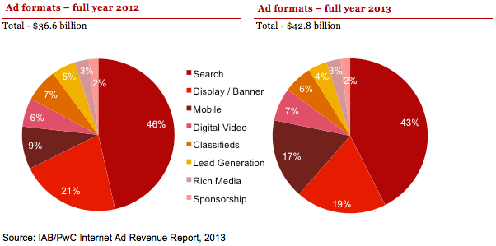

* Amounts may not equal 100% due to rounding and omission of minor categories.

# Historical format trends

## Search retains largest share of revenue, while Mobile grows fastest

* Search remains the leading format, representing a larger amount of the share than the next two closest formats combined (Display and Mobile). Decline in its overall share is attributed to growth in Mobile and Mobile Search, which is included in the Mobile category.
* All formats other than Digital Video and Rich Media are down slightly as a percentage of total revenue due to the substantial growth of Mobile.
* Mobile revenues continued to quickly gain share, representing 17% of total revenues in FY 2013, as compared with 9% reported in FY 2012 and 5% in FY 2011. While Mobile has eroded share of other formats, the Mobile format itself is comprised of multiple formats.

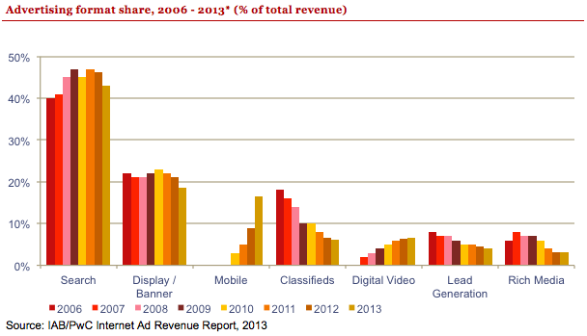

* Format definitions may have changed over the time period depicted, both within the survey process and as interpreted by survey respondents.

# Ad revenues by industry category

## Retail drives advertising, as dollars shift to digital

* Retail advertisers continue to represent the largest category of internet ad spending, accounting for 21% of total revenues in FY 2013, up from the 20% reported in FY 2012.
* Financial Services advertisers accounted for 13% of revenues in FY 2013, consistent with the 13% reported in FY 2012.
* Automotive advertisers accounted for 12% of revenues in FY 2013, consistent with the 12% of total reported in FY 2012.
* Telecom companies accounted for 9% of revenues in FY 2013, down from the 11% reported in FY 2012.
* Leisure Travel (airfare, hotels, and resorts) accounted for 8% of revenues in FY 2013, down from the 9% of revenues reported in FY 2012.
* Consumer Packaged Goods represented 7% in FY 2013, consistent with the 7% reported in FY 2012.
* Computing products advertisers represented 6% of revenues in FY 2013, down from the 8% reported in FY 2012.
* Pharmaceutical/Healthcare accounted for 5% in FY 2013, down from the 6% of revenues reported in FY 2012.
* Media accounted for 5% in FY 2013, consistent with the 5% reported in FY 2012.
* Entertainment accounted for 4% of FY 2013 revenues, consistent with the 4% reported in FY 2012.

# Industry advertising – year-over-year comparison

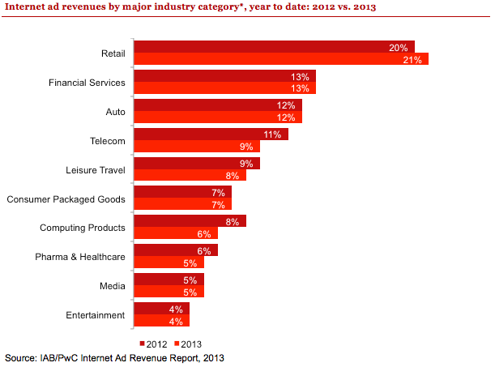

* Industry category definitions may have changed over the time period depicted, both within the survey process and as interpreted by survey respondents. Amounts do not total to 100% as minor categories are not displayed.

# Revenues by pricing model

## CPM-based pricing shows slight uptick

* Approximately 65% of FY 2013 revenues were priced on a performance basis, down from the 66% reported in FY 2012.
* Approximately 33% of FY 2013 revenues were priced on a cost per medium/thousand (CPM) or impression basis, up from the 32% reported in FY 2012.
* Approximately 2% of FY 2013 revenues were priced on a hybrid basis, consistent with the 2% reported in FY 2012.

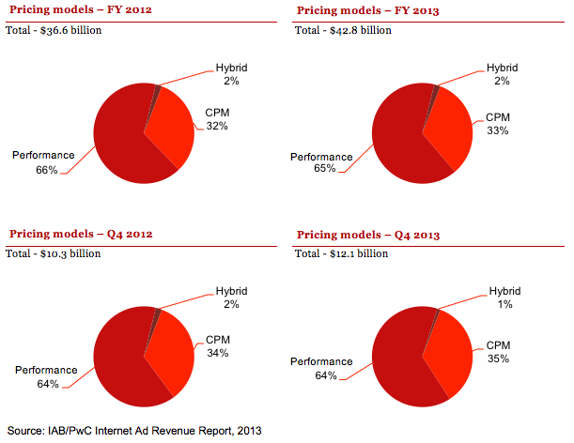

# Historical pricing model trends

## Performance-based pricing remains the preferred model

* Performance-based pricing, the leading pricing model since 2006, declined slightly to 65% of total revenue in 2013 from 66% in 2012.
* CPM/impression-based pricing gained in 2013, up to 33% of revenues from 32% in 2012. At 33% of total revenues, CPM is at its highest point since 2010.
* Hybrid pricing remained at 2% of total revenues in 2013, consistent with the 2% reported in 2012.

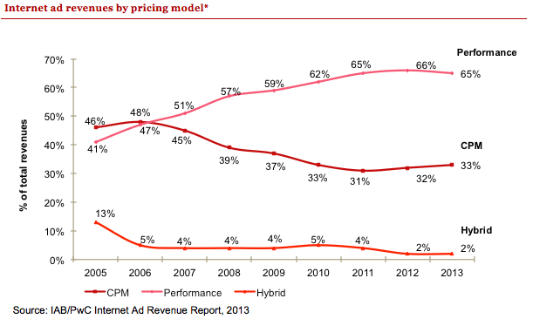

* Pricing model definitions may have changed over the time period depicted both within the survey process and as interpreted by survey respondents.

# Advertising market share by media

|  |
| --- |
| Internet advertising surpassed Broadcast Television* advertising revenue in 2013 Internet has continued to grow in share and significance when compared to other U.S. ad- supported media.† Internet advertising revenue now represents 57% of all Television (Broadcast and Cable) advertising.   * In 2013, Internet advertising exceeded Broadcast Television.* * In 2011, Internet advertising surpassed Cable Television.**   **Advertising revenue market share by media - 2013 ($ billions)** |

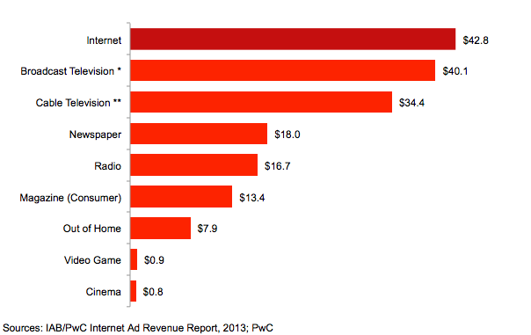

† The total U.S. advertising market includes other segments not charted here.

* Broadcast Television includes Network and Syndicated and Spot television advertising revenue.

** Cable Television includes National Cable Networks and Local Cable television advertising revenue.

# Historical advertising market share

## Internet advertising revenue growth outpaces other media outlets over the past nine years

Two forms of media have positive compound annual growth rates (CAGR) between 2005 through 2013: Cable Television at 4.8% and Internet at 16.6%.

In every year since 2005, the annual growth rates of Internet advertising have exceeded those of other advertising media. Internet advertising has experienced double-digit annual growth in every year except 2009; no other media has experienced double-digit growth in any year.

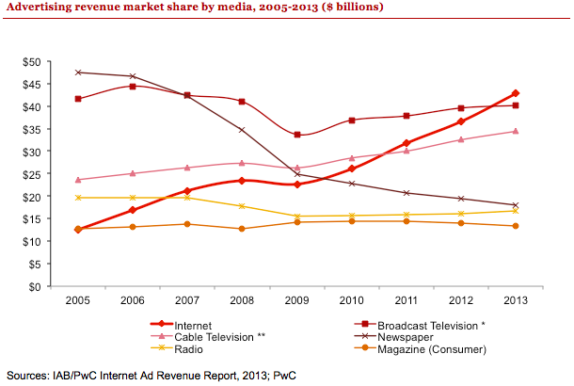

* Broadcast Television includes Network, Syndicated and Spot television advertising revenue.

** Cable Television includes National Cable Networks and Local Cable television advertising revenue.

|  |
| --- |
| Historical advertising growth of mediaWhile Mobile’s growth over the past four years is impressive, the Internet fared even better in its early years During the first four years of Broadcast TV, Cable TV, Internet, and Mobile, all media experienced tremendous advertising revenue growth.  While over time Cable TV has emerged as a major advertising medium, due to the capital intensive nature of the rollout and reliance on subscription fees, advertising revenue growth rates while impressive were not on par with the other media    **Comparative U.S. advertising media annual ad revenue growth for first 4 years**  **($ billions)** |

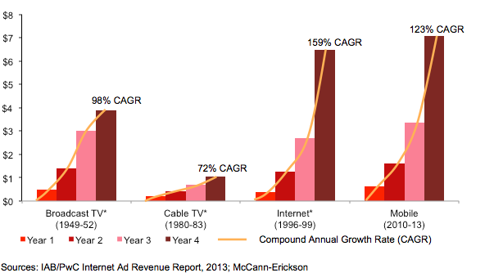

* Adjusted for Inflation

# Appendix

## Definitions of leading industry categories

The industry categories used in the "IAB Internet Advertising Revenue Report" were sourced from the North American Standard Industrial Classification (SIC) Manual.†

|  |  |
| --- | --- |
| Retail | Includes mail order/catalog, apparel, restaurants/fast food, home furnishings/textiles, toys, pet food/supplies, appliances, jewelry, drugstores, retail stores, and cosmetics stores. |
| Automotive | Includes all automotive-related categories including sale/purchase of vehicles and parts and maintenance. |
| Entertainment | Includes film, music, TV, box office, video games, and amusement & recreation. |
| Consumer packaged goods | Includes packaged goods, food products, household products, and tobacco. |
| Leisure travel | Includes travel, hotel, airlines, and resorts. |
| Computing products | Includes hardware (computers, computer storage devices, and computer peripheral equipment), consumer electronics, prepackaged software (operating, utility, and applications programs), local area network systems and network systems integration, computer processing, and data preparation and data processing services. |
| Financial Services | Includes commercial banks, credit agencies, personal credit institutions, consumer finance companies, loan companies, business credit institutions, and credit card agencies. Also includes companies engaged in the underwriting, purchase, sale, or brokerage of securities and other financial contracts. |
| Telecommun-ications | Includes point-to-point communications services, including cellular phone services, paging services, wireless internet access, and wireless video services. Includes multichannel video providers on a subscription fee basis (e.g., cable television, wireless cable television, and direct broadcast satellite services). |
| Pharmaceutical & Healthcare | Includes pharmaceutical products, facilities, services, researchers, and biological products. Also comprises establishments providing healthcare and social assistance for individuals as well as personal care, toiletries, and cosmetic products. |
| Media | Includes establishments primarily engaged in radio and television broadcasting (network and station) including commercial, religious, educational, and other radio or television stations. Also includes establishments primarily engaged in publishing newspapers, periodicals, and books. |

†Survey participants reported results based on the 20 industry categories listed on page 25, which were used specifically for the "IAB Internet Advertising Revenue Report." This is consistent with other relevant industry categorization sources that measure advertising spending by industry. For purposes of this report, PwC classified a number of individual categories under “Retail.”

## Definitions of advertising formats

|  |  |
| --- | --- |
| Display Advertising | Advertiser pays an online company for space on one or more of the online company’s pages to display a static or linked banner or logo. |
| Sponsorship | Advertiser pays for custom content and/or experiences, which may or may not include ad elements such as display advertising, brand logos, advertorial, or pre-roll video. Sponsorships fall into several categories:  Spotlights are custom-built pages incorporating an advertiser’s brand and housing a collection of content usually around a theme  Advergaming can range from an advertiser buying all the ad units around a game or a “sponsored by” link to creating a custom branded game experience  Content & Section Sponsorship is when an advertiser exclusively sponsors a particular section of the site or email (usually existing content) re-skinned with the advertiser’s branding  Sweepstakes & Contests can range from branded sweepstakes on the site to a full-fledged branded contest with submissions and judging |
| Email | Banner ads, links or advertiser sponsorships that appear in email newsletters, email marketing campaigns and other commercial email communications. This includes both ads within an email or the entire email. |
| Search | Fees advertisers pay online companies to list and/or link their company site domain name to a specific search word or phrase (includes paid search revenues). Search categories include:  Paid listings – payments made for clicks on text links that appear at the top or side of search results for specific keywords. The more a marketer pays, the higher the position it gets. Marketers only pay when a user clicks on the text link.  Contextual search – payments made for clicks on text links that appear in an article based on the context of the content, instead of a user-submitted keyword. Payment only occurs when the link is clicked.  Paid inclusion – payments made to guarantee that a marketer's URL is indexed by a search engine (i.e. advertiser isn’t paid only for clicks, as in paid listings).  Site optimization – payments made to optimize a site in order to improve the site’s ranking in search engine results pages (SERPs). (For example, site owner pays a company to tweak the site architecture and code, so that search engine algorithms will better index each page of the site). |
| Lead Generation | Fees paid by advertisers to online companies that refer qualified potential customers (e.g., auto dealers which pay a fee in exchange for receiving a qualified purchase inquiry online) or provide consumer information (demographic, contact, behavioral) where the consumer opts in to being contacted by a marketer (email, postal, telephone, fax). These processes are priced on a performance basis (e.g., cost-per-action, -lead or -inquiry), and can include user applications (e.g., for a credit card), surveys, contests (e.g., sweepstakes) or registrations. |
| Classifieds and Auctions | Fees paid to advertisers by online companies to list specific products or services (e.g., online job boards and employment listings, real estate listings, automotive listings, auction-based listings, yellow pages). |
| Rich Media | Display-related ads that integrate some component of streaming interactivity. Rich media ads often include flash or java script, but not content, and can allow users to view and interact with products or services (e.g., scrolling or clicking within the ad opens a multimedia product description, expansion, animation, video or a “virtual test-drive” within the ad).  All IAB Rising Stars ad formats are considered Rich Media. Digital audio ads that appear before, during or after audio content (e.g., streaming radio, podcasts, etc.) are also considered Rich Media.  Video commercials that appear in video players are considered Digital Video Ads, not Rich Media.  “Interstitials” have been consolidated within the rich media category and represent full- or partial-page text and image server-push advertisements which appear in the transition between two pages of content. Forms of interstitials can include a variation of the following terms:  Splash screens – a preliminary page that precedes the regular home page of a website that usually promotes a particular site feature or provides advertising. A splash page is timed to move onto the home page after a short period of time.  Pop-up ads and pop-under ads – an advertisement that appear in a separate window which automatically loads over an existing content window, without an associated banner.  Daughter windows – an advertisement that runs in a separate window associated with a concurrently displayed banner. The content and banner are typically displayed first, followed by the daughter window.  Superstitials – ads that are distinct from interstitials because of the much higher ad quality, and that they play instantly (ads are fully downloaded before they are displayed). |

## Definitions of advertising formats (cont.)

|  |  |
| --- | --- |
| Digital Video Advertising | Advertising that appears before, during or after digital video content in a video player (i.e. pre-roll, mid-roll, post-roll video ads). Digital Video Ads include TV commercials online and can appear in streaming content or in downloadable video. Display-related ads on a page (that are not in a player) that contain video are categorized as rich media ads.  Video Overlays are also categorized as Digital Video Advertising. Video overlays include small ads that appear on top of digital video content. They can appear to be display, video, rich media, text or another ad format but are contained within the video player. |
| Mobile Advertising | Advertising tailored to and delivered through wireless mobile devices such as smartphones (e.g. Blackberry, iPhone, Android, etc.), feature phones (e.g. lower-end mobile phones capable of accessing mobile content), and media tablets (e.g. iPad, Samsung Galaxy Tablet, etc.). Typically taking the form of static or rich media display ads, text messaging ads, search ads, or audio/video spots, such advertising generally appears within mobile websites (e.g. websites optimized for viewing on mobile devices), mobile apps (e.g. applications for Smartphones running iOS, Android, Windows Mobile or other operating systems), text messaging services (i.e. SMS, MMS) or within mobile search results (i.e., 411 listings, directories, mobile-optimized search engines). |

## Survey scope and methodology

### Survey scope

The Interactive Advertising Bureau (IAB) retained PwC to establish a comprehensive standard for measuring the growth of internet/online/mobile advertising revenues. The "IAB internet advertising revenue report" is part of an ongoing IAB mission to provide an accurate barometer of internet advertising growth.

To achieve differentiation from existing estimates and accomplish industry-wide acceptance, key aspects of the survey include:

* Obtaining historical data directly from companies generating internet/online/mobile advertising revenues;
* Making the survey as inclusive as possible, encompassing all forms of internet/online/mobile advertising, including websites, consumer online services, ad networks, mobile devices, and e-mail providers; and
* Ensuring and maintaining a confidential process, releasing only aggregate data.

### Methodology

PwC performs the following:

* Compiles a database of industry participants selling internet/online and mobile advertising revenues
* Conducts a quantitative mailing survey with leading industry players, including Web publishers, ad networks, commercial online service providers, mobile providers, e-mail providers, and other online media companies
* Acquires supplemental data through the use of publicly disclosed information
* Requests and compiles several specific data items, including monthly gross commissionable advertising revenue by industry category and transaction
* Identifies non-participating companies and applies a conservative revenue estimate based on available public sources
* Analyzes the findings, identifies and reports key trends

## Survey industry categories

|  |  |  |
| --- | --- | --- |
| Automotive  Beer/Wine/Liquor  Business Products/Services  Computers (Hardware/Software) and Consumer Electronics  Consumer Packaged Goods, Food, Non-Alcoholic Beverages and Candy  Educational Services  Entertainment (Film, Music, TV, Box Office, Video Games, Amusement/Recreational) | Financial Services (Banks, Insurance, Securities, Mortgages)  Personal Care, Toiletries, and Cosmetics  Drugs and Remedies  Manufacturing  Media  Professional Sports and Sporting & Athletic Goods  Real Estate | Restaurants/Fast Food  Retail, Mail Order, Catalogs and Apparel  Telecommunications: Telephony, Cable/Satellite TV Services, ISPs  Toys/Games  Leisure Travel (Airfare, Hotels, Resorts)  Business Travel (Airfare, Hotels, Resorts) |

## About the Interactive Advertising Bureau

The Interactive Advertising Bureau (IAB) is comprised of more than 600 leading media and technology companies that are responsible for selling 86% of online advertising in the United States. On behalf of its members, the IAB is dedicated to the growth of the interactive advertising marketplace, of interactive’s share of total marketing spend, and of its members’ share of total marketing spend. The IAB educates marketers, agencies, media companies and the wider business community about the value of interactive advertising. Working with its member companies, the IAB evaluates and recommends standards and practices and fields critical research on interactive advertising. Founded in 1996, the IAB is headquartered in New York City with a Public Policy office in Washington, D.C. For more information, please visit iab.net.

## Overall report guidance provided by IAB leadership

|  |  |  |
| --- | --- | --- |
| Executive Committee | | |
| President and CEO  **Randall Rothenberg** IAB  **Denise Warren**  The New York Times Company  **Randy Kilgore**  Tremor Media | Chairman  **Vivek Shah**  Ziff Davis  **Neal Mohan**  Google  **David Moore**  Xaxis | Vice Chair  **David Morris**  CBS Interactive  **Bill Todd**  Conversant Media  **Lisa Utzschneider**  Amazon.com  **Rik van der Kooi** Microsoft Advertising |

|  |  |  |
| --- | --- | --- |
| Ex-Officio | | |
| Founding Chairman  **Rich LeFurgy** Archer Advisors | Treasurer  **Bruce Gordon** Disney Interactive Media Group | Secretary  **Joe Rosenbaum** Reed Smith LLP |

|  |  |  |
| --- | --- | --- |
| Board of Directors | | |
| **Joe Apprendi** Collective  **David Brinker**  News Corporation  **Ned Brody**  Yahoo!  **Kevin Conroy** Univision  **Jory Des Jardins**  BlogHer  **Eric Franchi**  Undertone  **Michael Friedenberg**  IDG  **Joan Gillman** Time Warner Cable Media  **Curt Hecht**  The Weather Channel  **Mark Howard**  Forbes.com | **Eric Johnson**  ESPN.com  **Neil O. Johnston**  CMG Digital  **Mike Keriakos**  Everyday Health  **Seth Ladetsky**  Turner Broadcasting System  **David Lawenda**  Facebook  **Jean-Philippe Maheu**  Twitter  **Suzanne McDonnell**  Discovery Communications  **Jim Norton**  AOL  **Leslie Picard**  Time Inc.  **Penry Price**  LinkedIn | **Scott Schiller**  NBC Universal Digital Media  **Drew Schutte**  Condé Nast  **Tad Smith**  Cablevision Systems Corporation  **Mollie Spilman**  Millennial Media  **Jon Steinberg**  Buzzfeed  **John Trimble**  Pandora  **Jacob Weisberg**  Slate  **Mike Welch**  AT&T AdWorks  **Troy Young**  Hearst Magazines Digital Media |

## PwC New Media Group with the Entertainment, Media, and Communications practice

As business, accounting, and tax advisors to many of the world’s leading Entertainment, Media, and Communications (EMC) and Technology (Tech) companies, PwC (www.pwc.com) has an insider’s view of trends and developments driving the industry. With approximately 1,200 practitioners serving EMC and Tech clients in the United States, PwC is deeply committed to providing clients with industry expertise and resources. In recent years, our pioneering work in EMC and Tech has included developing strategies to leverage digital technology, identifying new sources of financing, and marketplace positioning in industries characterized by consolidation and transformation. Our experience reaches across all geographies and segments of the EMC and Tech sectors, including broadband, wireless, the internet, music, film, television, publishing, advertising, gaming, theme parks, computers and networking, and software. With thousands of practitioners around the world, we're always close at hand to provide deep industry knowledge and resources.

PwC’s New Media Group was the first practice of its kind at a Big Four firm. Currently located in New York, Los Angeles, Boston, Seattle, and the Bay Area, our New Media Group includes accounting, tax, and consulting professionals who have broad and deep experience in the three areas that converge to form new media: advanced telecommunications, enabling software, and content development/distribution.

**Our services include:**

* Business assurance services
* Web audience measurement and advertising delivery auditing and advisory
* IAB Measurement Certification Compliance auditing
* Privacy policy structuring, attestation, and compliance advisory
* Mergers & acquisitions assistance
* Tax planning and compliance
* Capital sourcing and IPO assistance

For more information about our New Media Group, contact one of the following PwC professionals:

|  |  |  |
| --- | --- | --- |
| New York  **David Silverman**  Partner, Assurance Services  646.471.5421  [***david.silverman@us.pwc.com***](mailto:david.silverman@us.pwc.com) | New York  **Russ Sapienza**  Partner, Advisory Services  646.471.1517  [***russell.j.sapienza@us.pwc.com***](mailto:russell.j.sapienza@us.pwc.com) | New York  **Michael Altschul**  Manager, Advisory Services  646.471.4903  [***michael.altschul@us.pwc.com***](mailto:michael.altschul@us.pwc.com) |
|  |  |  |
| Boston  **Vic Petri**  Partner, Assurance Services  617.478.1698  [***victor.petri@us.pwc.com***](mailto:victor.petri@us.pwc.com) | San Jose  **Mike Pearl**  Partner, Assurance Services  408.817.3801  [***michael.pearl@us.pwc.com***](mailto:michael.pearl@us.pwc.com) | Seattle  **Suzanne Faulkner**  Partner, Assurance Services  206.398.3550  [***suzanne.faulkner@us.pwc.com***](mailto:suzanne.faulkner@us.pwc.com) |

www.pwc.com/e&m